**Chulalongkorn University**

**Programming methodology 2110215**

**Semester 2 Academic Year 2021**

**Final Project Documentation**

**“Space Game”**

**Created by**

Jirawat Lengnoi 6431307421

Natthasith Wiriyayothin 6431318321

**Space Game**

**Introduction**

“Space Game” was inspired by a card game battle called “HearthStone”. The story of this game is similar to HearthStone but the difference is the player doesn’t have to draw any cards from the deck because this game doesn’t have a deck. Instead, players have to think carefully while they buy the card from the shop.

The main objective is to find which player's health reaches 0 first. The player whose health reaches 0 first will lose. And the remaining player will be the winner.

**Heroes**

In this game, a character will be called a Hero. This game has 5 heroes. 1. Red Mage 2. Light Paladin 3. Ogre King 4. Light Hawk and lastly 5. Bad Witch.

**1. Red Mage**

This hero has the power called “Fireblast”.

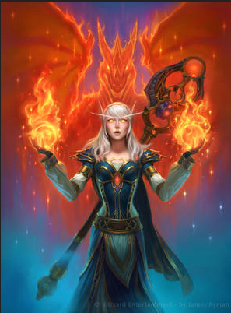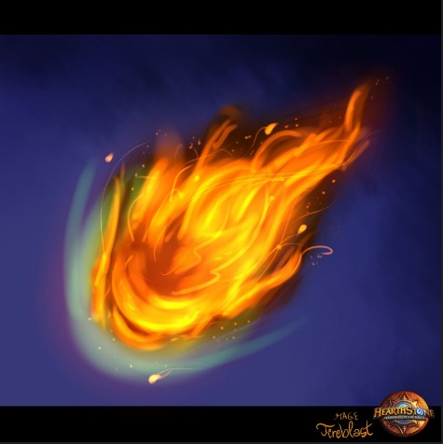

Figure 1 - Red Mage and Fireblast picture

**2. Light Paladin**

This hero has the power called “Heal”

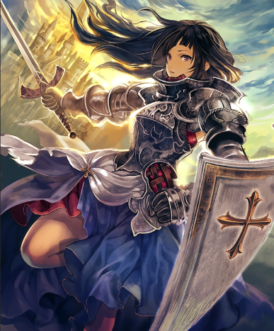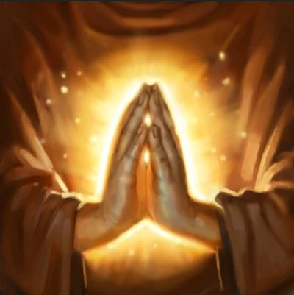

Figure 2 - Light Paladin and Heal picture

**3. Ogre King**

This hero has the power called “Quick Recruit”

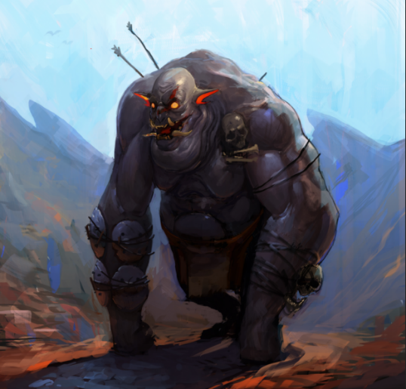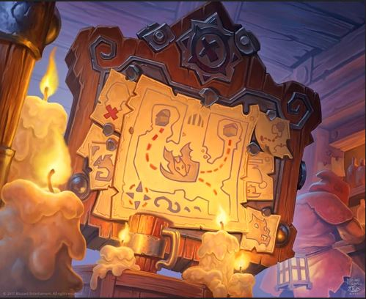

Figure 3 - Ogre King and Quick Recruit picture

**4. Light Hawk**

This hero is the hero that has its own power called “Buff”

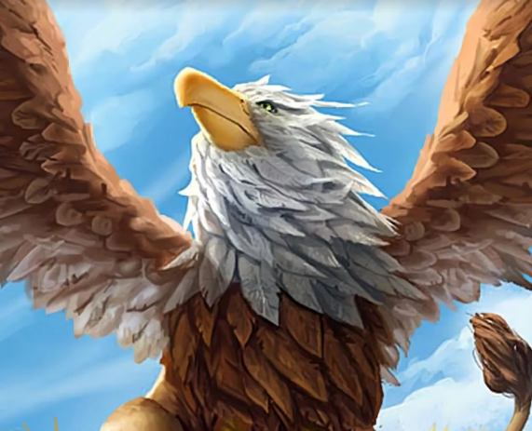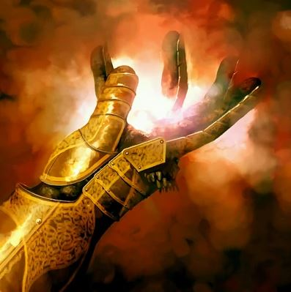

Figure 4 - Light Hawk and Buff picture

**5. Bad Witch**

This hero is the hero that has its own power called “Inner Rage”

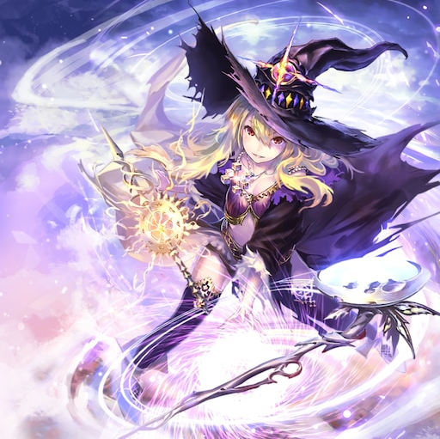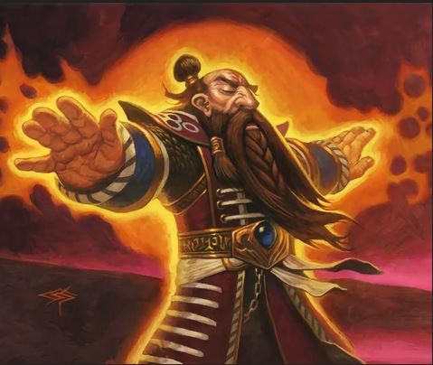

Figure 5 - Bad Witch and Inner Rage picture

**Minion**

In this game, there will be 3 levels of minions. Each level has 5 minions. Some minions have their unique way of attacking other minions. Also, the minion has its own cost for players to buy. The cost value of a minion depends on the strength of the minions according to the creators’ thoughts.

**Level 1**

**1. Dog**

This minion has 1 base attack damage and its base health is 2. Its special attack occurs when it brawls with another minion, the attack of this minion increases by 3. The cost of this minion is 5 mana.

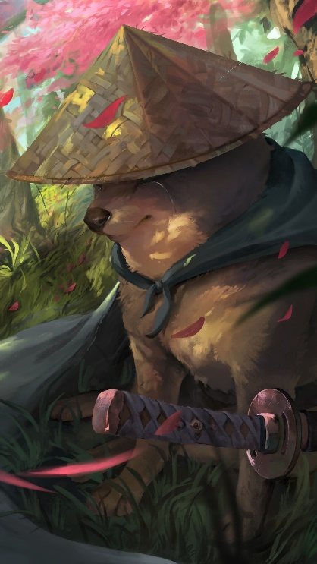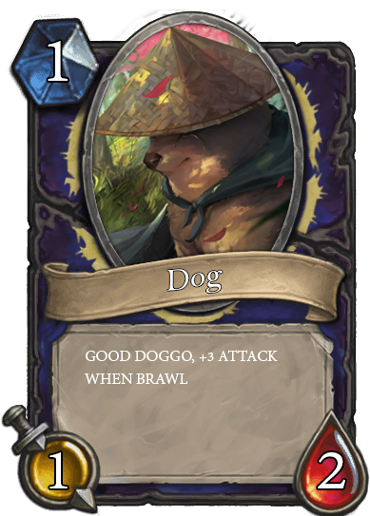

Figure 6 - Dog and Framed Dog with its attack and its health

**2. Fire spirit**

This minion has 3 base attack damage and its base health is 1. This minion doesn’t have any special effects. The cost of this minion is 5 mana.

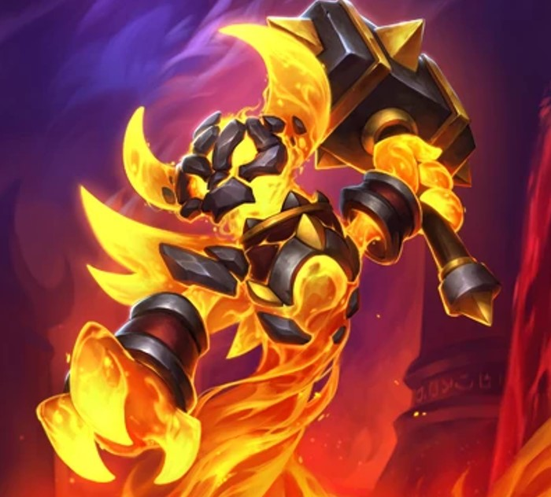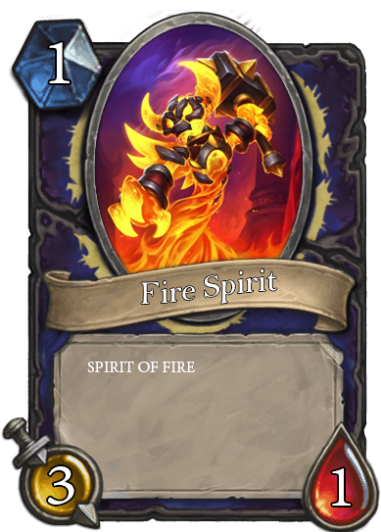

Figure 7 - Fire Spirit and Framed Fire Spirit with its attack and its health

**3. Gobuta**

This minion has 1 base attack damage and its base health is 3. This minion doesn’t have any special effects. The cost of this minion is 5 mana.

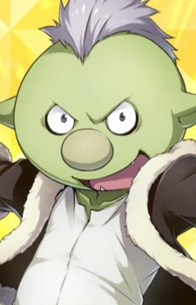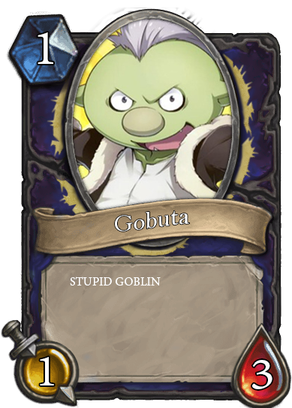

Figure 8 - Gobuta and Framed Gobuta with its attack and its health

**4. Spider**

This minion has 2 base attack damage and its base health is 2. This minion doesn’t have any special effects. The cost of this minion is 5 mana.

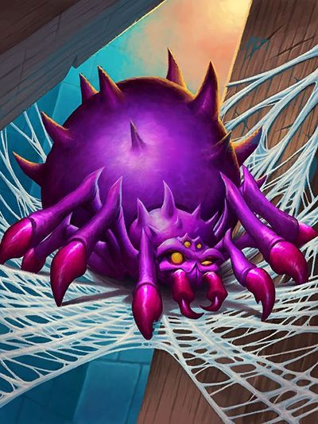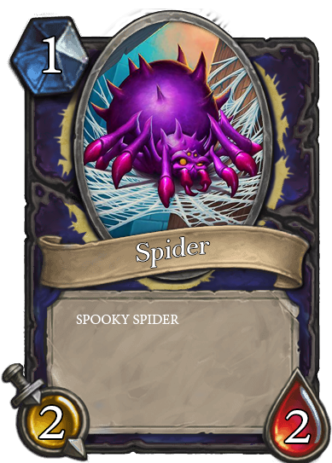

Figure 9 - Spider and Framed Spider with its attack and its health

**5. George**

This minion has 1 base attack damage and its base health is 4. Its special attack occurs when it brawls with another minion while it is still alive. The health of this minion will be at its base health. The cost of this minion is 8 mana.

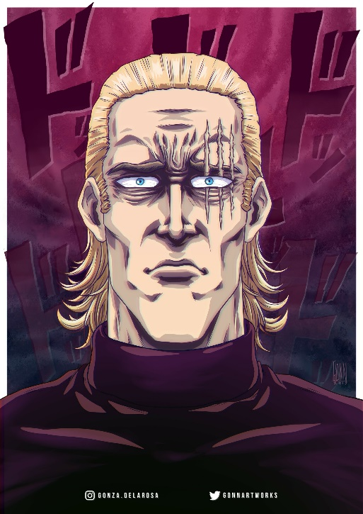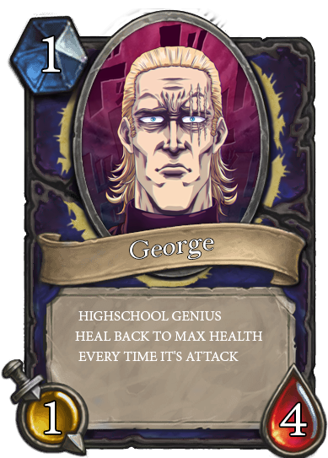

Figure 10 - George and Framed George with its attack and its health

**Level 2**

**6. Hob Goblin**

This is the minion has 5 base attack damage and its base health is 5. This minion doesn’t have any special effects. The cost of this minion is 10 mana.

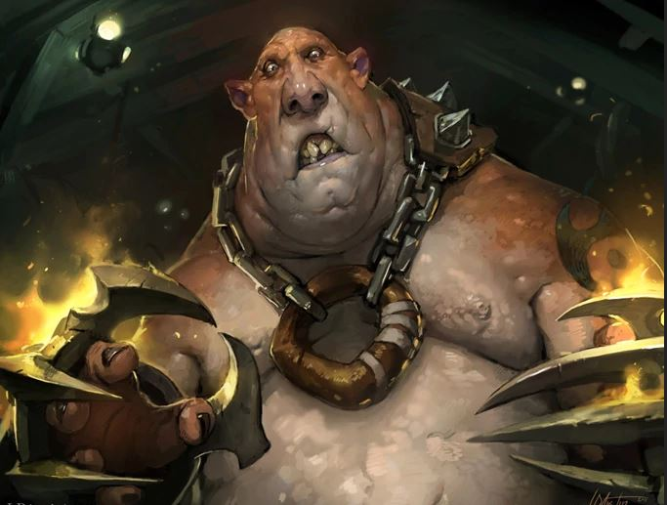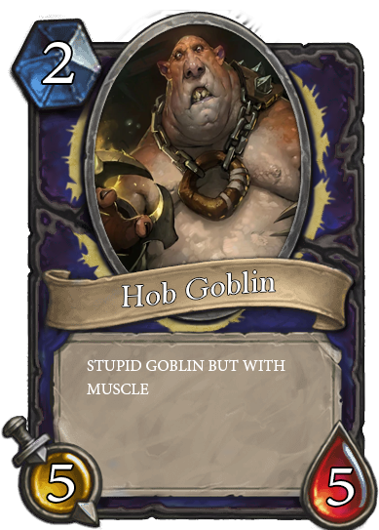

Figure 11 - Hob Goblin and Framed Hob Goblin with its attack and its health

**7. Knight**

This minion has 3 base attack damage and its base health is 7. This minion doesn’t have any special effects. The cost of this minion is 10 mana.

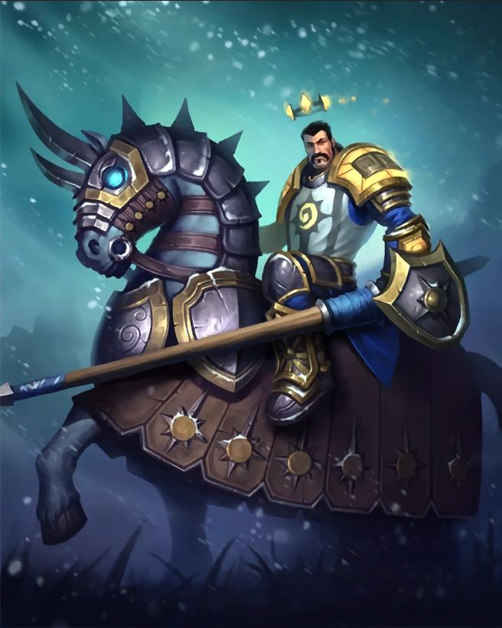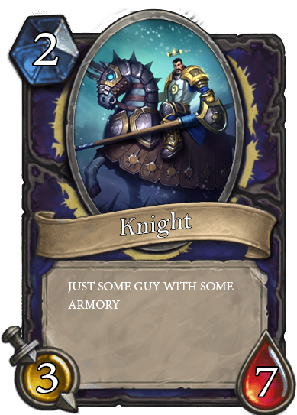

Figure 12 - Knight and Framed Knight with its attack and its health

**8. Muscle Dude**

This minion has 9 base attack damage and its base health is 9. Its special attack occurs when it brawls with another minion or player, the health of this minion and its attack will decrease by 2 every time it brawls and, it will be dead when the health is less than 1. The cost of this minion is 10 mana.

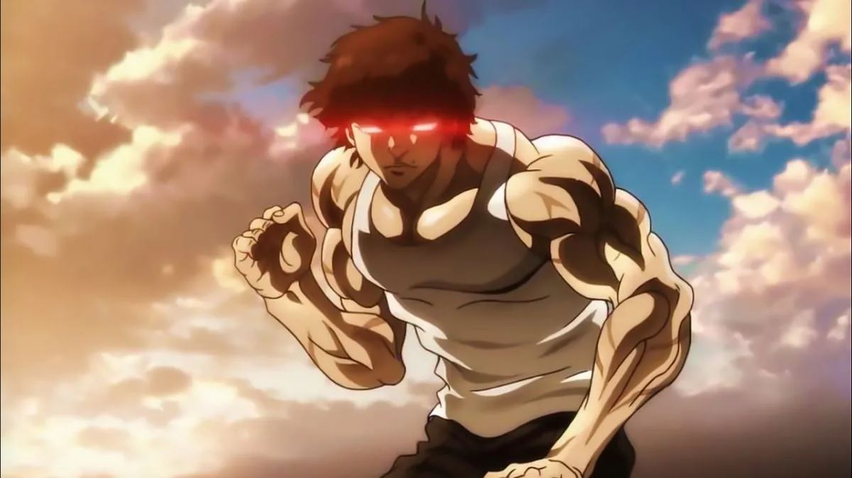 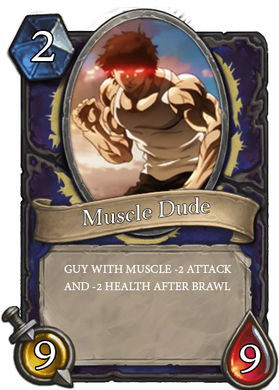

Figure 13 - Muscle Dude and Framed Muscle Dude with its attack and its health

**9. Spider Cave**

This minion has 1 base attack damage and its base health is 5. Its special attack is when it brawls with another minion, the target minion will be instantly dead, the cost of this minion is 10 mana.

. 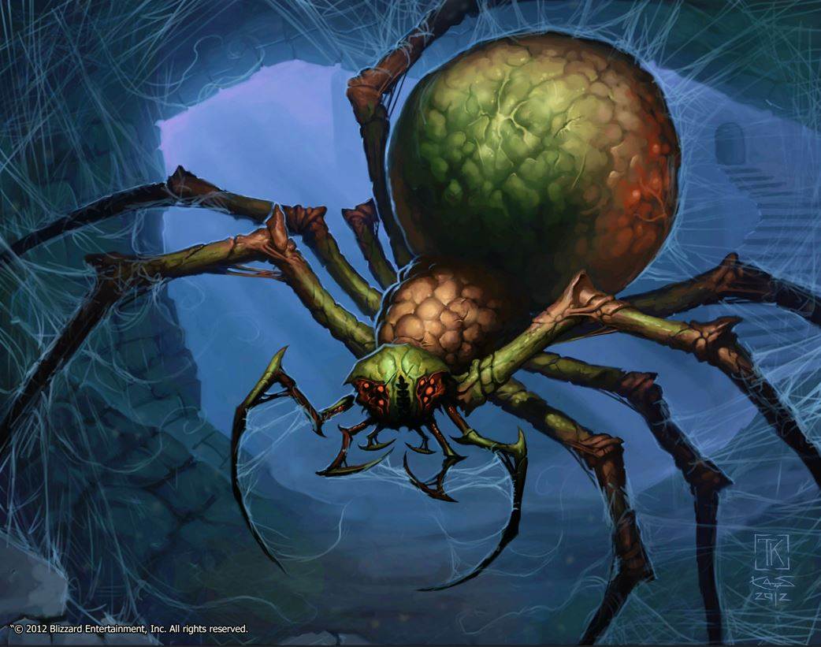 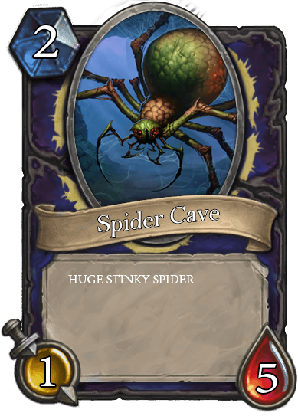

Figure 14 - Spider Cave and Framed Spider Cave with its attack and its health

**10. Earth Spirit**

This minion has 3 base attack damage and its base health is 15. This minion doesn’t have any special effects. The cost of this minion is 13 mana.

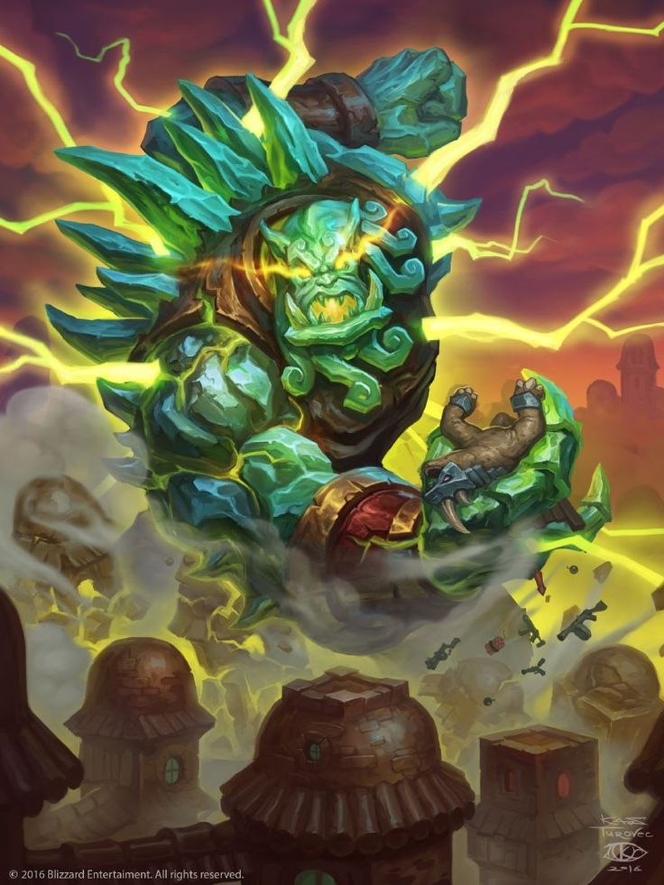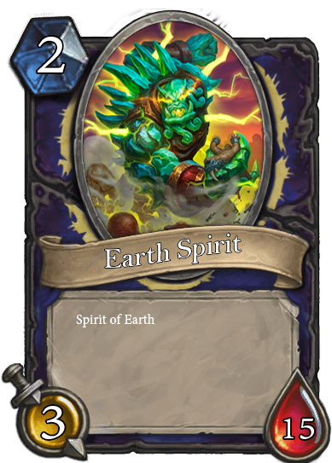

Figure 15 - Earth Spirit and Framed Earth Spirit with its attack and its health

**Level 3**

**11. Dragon**

This minion has 12 base attack damage and its base health is 12. This minion doesn’t have any special effects. The cost of this minion is 15 mana.

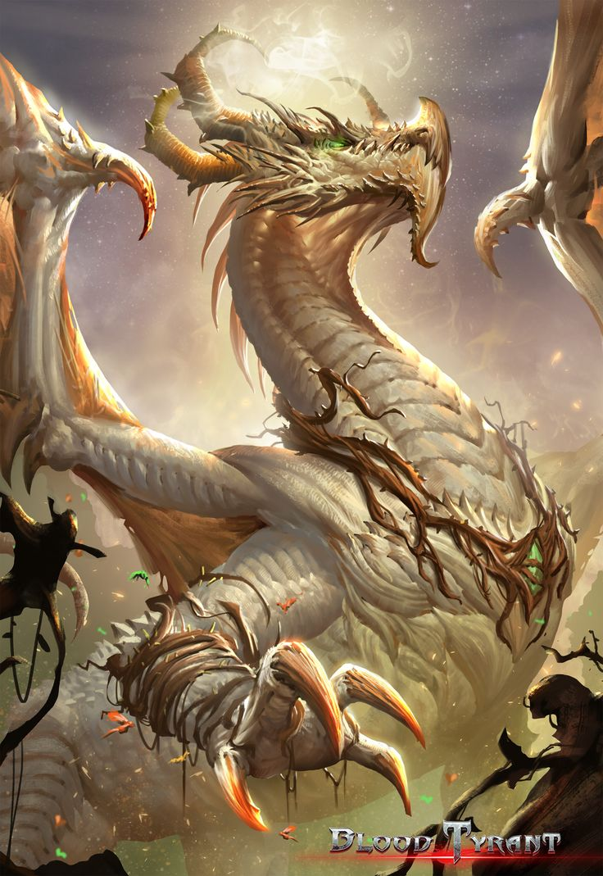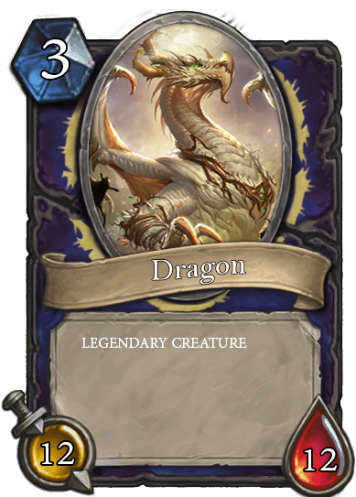

Figure 16 - Dragon and Framed Dragon with its attack and its health

**12. Priest**

This minion has 20 base attack damage and its base health is 20. Its special attack occurs when it brawls with another minion, the target player receives 15 additional health points. The cost of this minion is 15 mana.

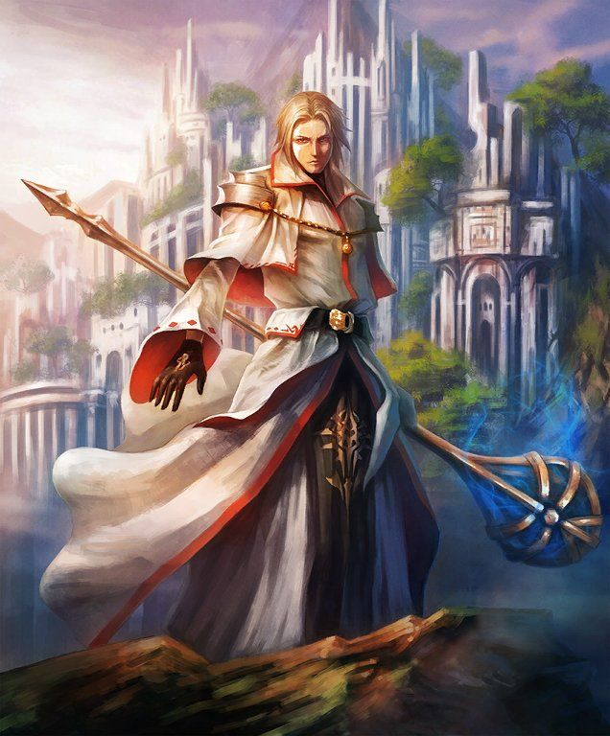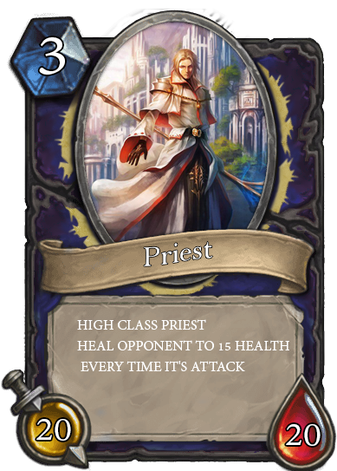

Figure 17 - Priest and Framed Priest with its attack and its health

**13. Ragnaros**

This minion has 8 base attack damage and its base health is 8. The special effect of this minion is always dealing 8 attack damage when attacking the opponent directly. The cost of this minion is 15 mana.

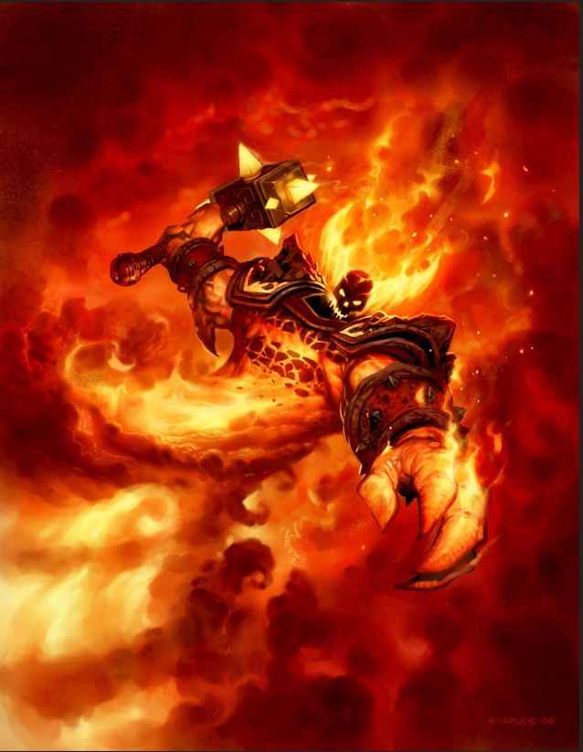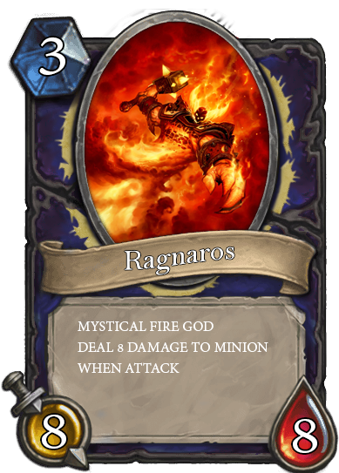

Figure 18 - Ragnaros and Framed Ragnaros with its attack and its health

**14. Real Warrior**

This minion has 8 base attack damage and its base health is 8. This minion special effects occur if this minion is dead during its own attack, the owner of this card wins. The cost of this minion is 30 mana.

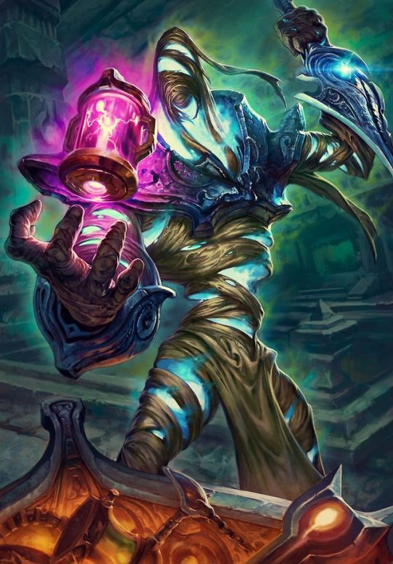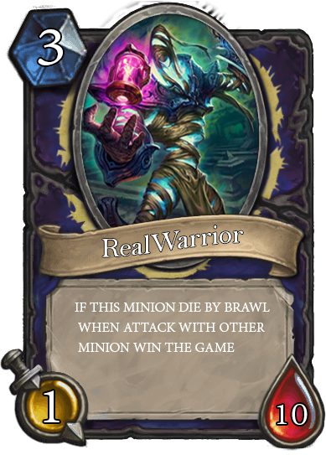

Figure 19 - Real Warrior and Framed Real Warrior with its attack and its health

**15. Yog**

This minion has 0 base attack damage and its base health is 30. This minion has special effects when it attacks, the opponent field will be clear instantly but it can’t deal damage to the opponent. The cost of this minion is 40 mana.

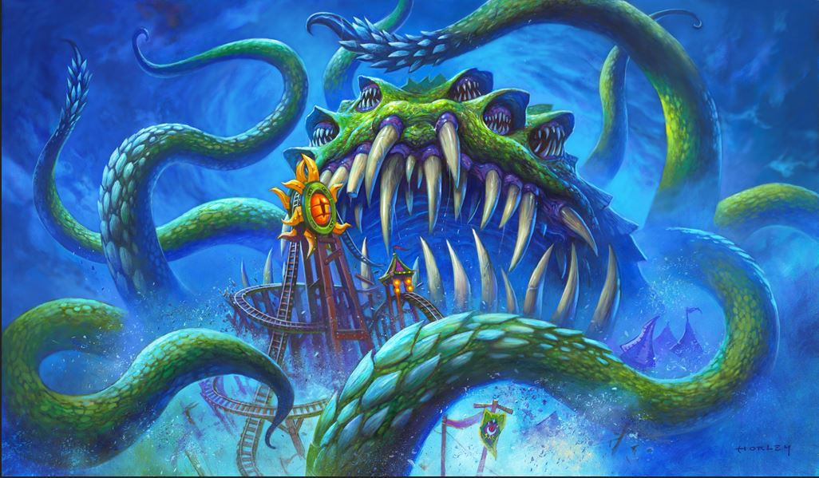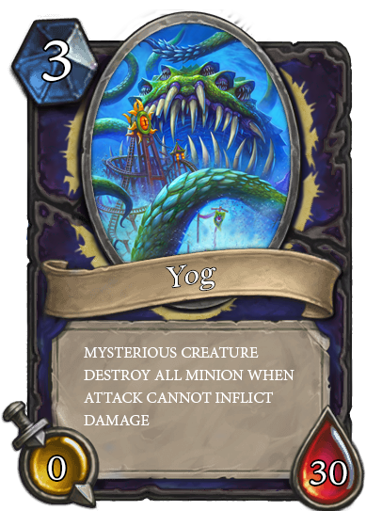

Figure 20 - Yog and Framed Yog with its attack and its health

**Spell**

In this game, there will be 3 levels of spells. Each level has 5 spells. The cost of each spell is designed to be how strong the spell is according to the creators’ thoughts. Every spell has to be cast when the field has minions except Quick Recruit, Boink, and Legend

**Level 1**

* 1. **Buff**

This spell increases 1 attack and 2 health to the target minion. The cost of this spell is 4 mana.

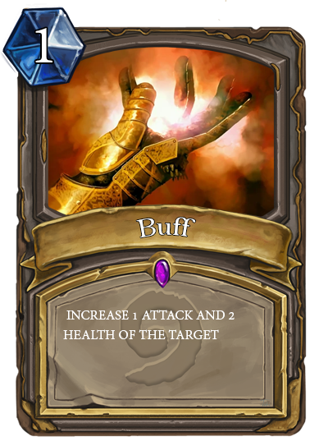

Figure 21 - Buff and Framed Buff with its effect

**2. Fireblast**

This spell can only target minions. The effect of this spell occurs when this spell is cast to the opponent’s minion, it reduces 1 health of the target minion. The cost of this spell is 3 mana.

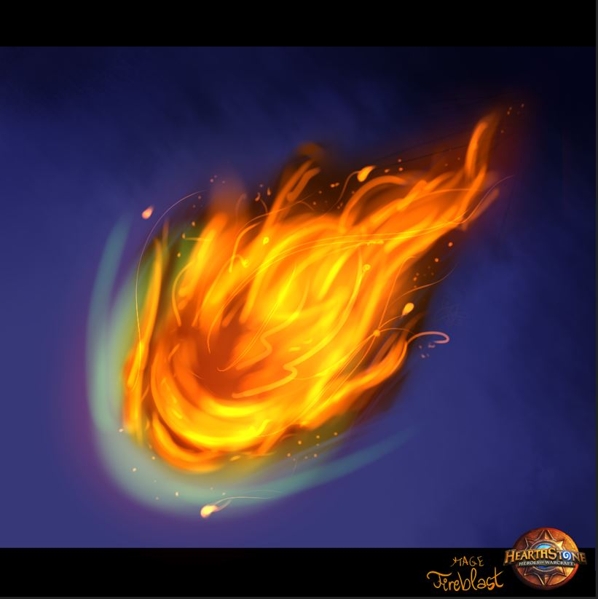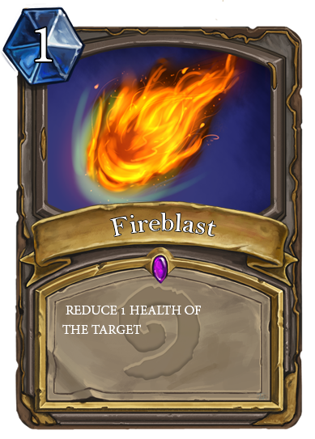

Figure 22 - Fireblast and Framed Fireblast with its effect

**3. Heal**

This spell increases 1 attack and 2 health to the target minion. The cost of this spell is 3 mana. This spell can’t be used against the opponent’s minion. The cost of this spell is 2 mana.

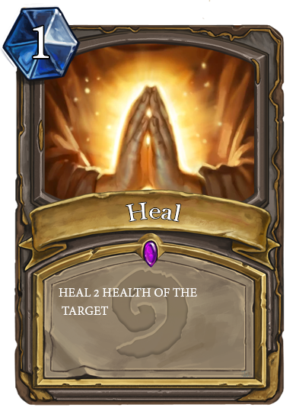

Figure 23 - Heal and Framed Heal with its effect

**4. Inner Rage**

This spell sets the minion target attack to equal its health. The cost of this spell is 3 mana.

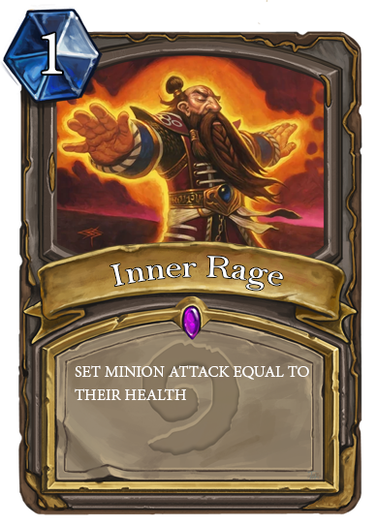

Figure 24 - Inner Rage and Framed Inner Rage with its effect

**5. Quick Recruit**

This spell summons “Gobuta” to the player field. This spell can’t be used against the opponent’s minion. The cost of this spell is 5 mana.

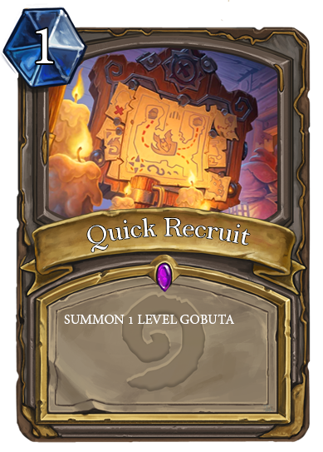

Figure 25 - Quick Recruit and Framed Quick Recruit with its effect

**Level 2**

**6. Binding Heal**

This spell increases 5 health of the selected minion and the player health. This spell can’t be used against the opponent minion. The cost of this spell is 5 mana.

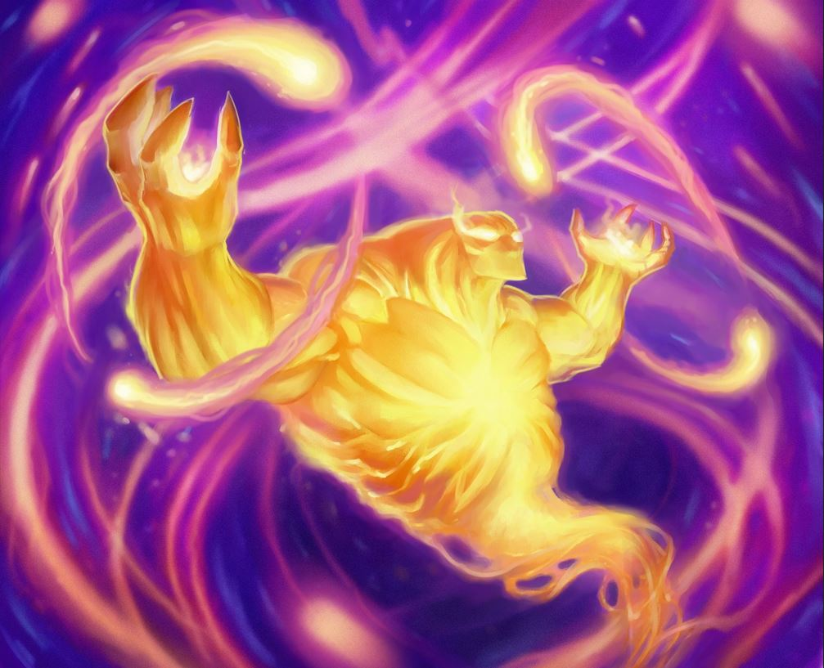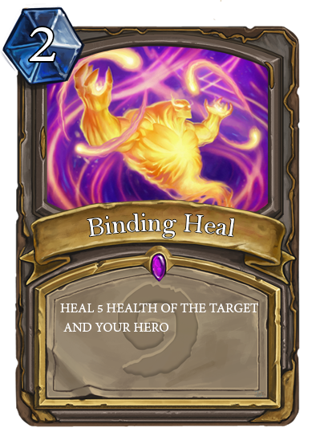Figure 26 - Binding Heal and Framed Binding Heal with its effect

**7. Boink**

This spell reduces opponent health by 5. The cost of this spell is 8 mana.

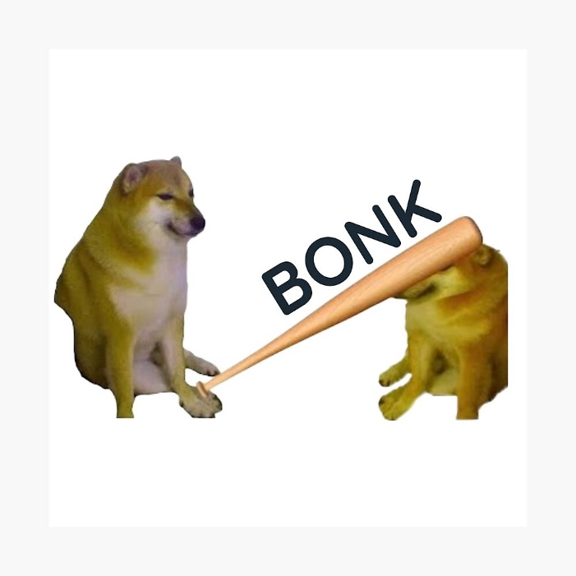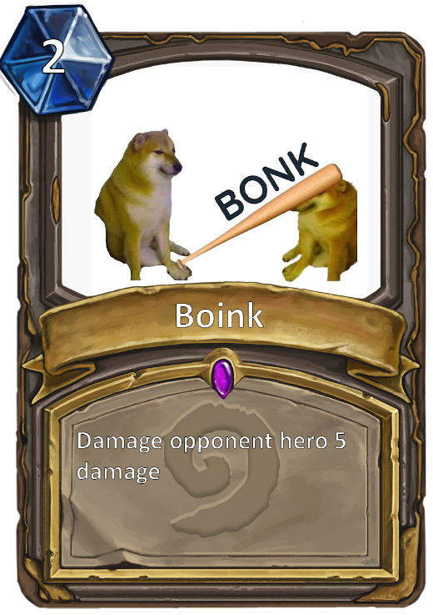

Figure 27 - Boink and Framed Boink with its effect

**8. Fireball**

This spell can be cast on the opponent minion only. This spell reduces target minion health by 6. The cost of this spell is 6 mana.

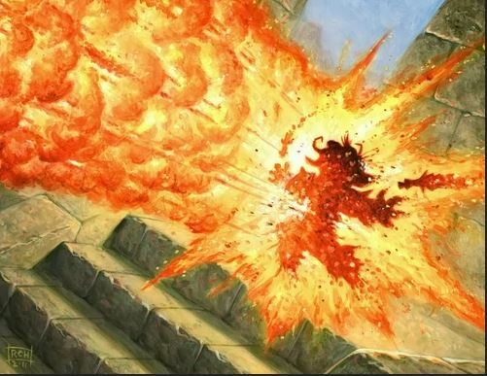 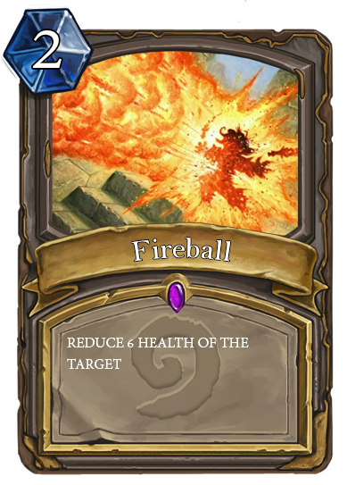

Figure 28 - Fire Ball and Framed Fire Ball with its effect

**9. Fire Rings**

This spell can only be cast when the opponent's field has minions. This spell reduces all of the minions in opponent field health by 1. The cost of this spell is 6 mana.

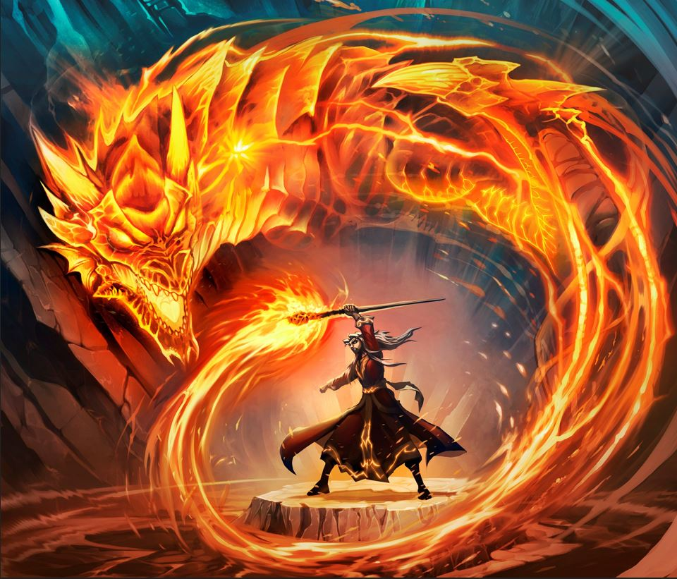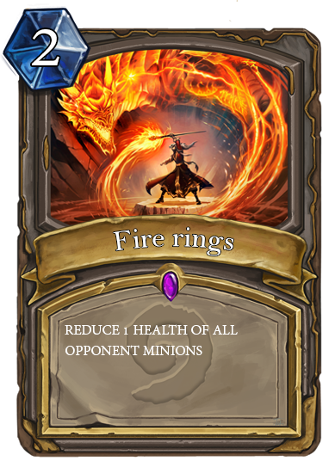

Figure 29 - Fire Rings and Framed Fire Rings with its effect

**10. Mass Heal**

This spell can only be cast when the player’s field has minion and this can’t be cast on the opponent’s field. This spell increases 2 health of all of the player’s minion's health. The cost of this spell is 5 mana.

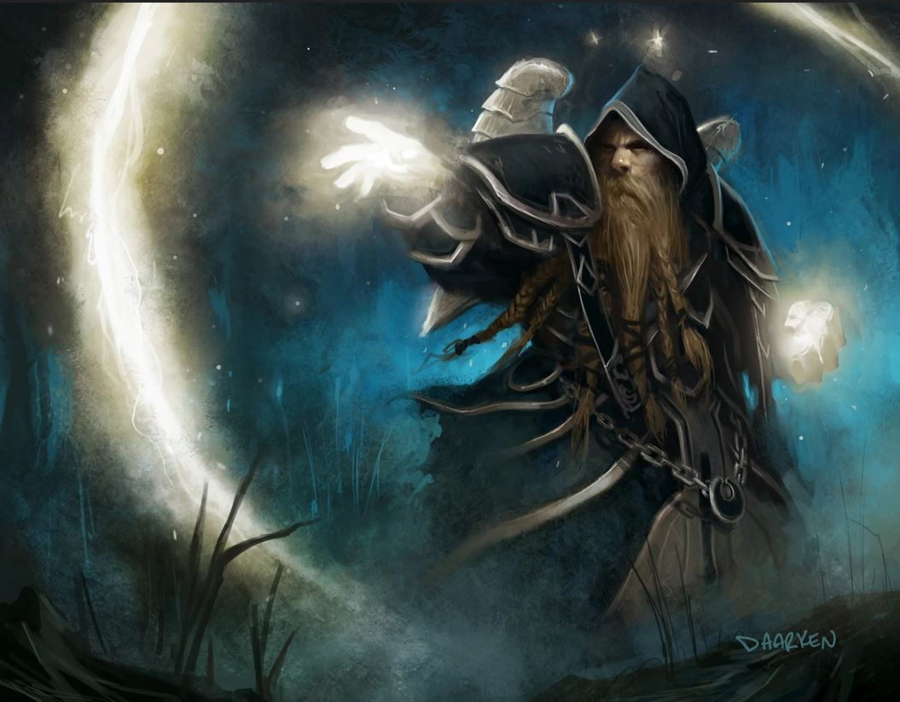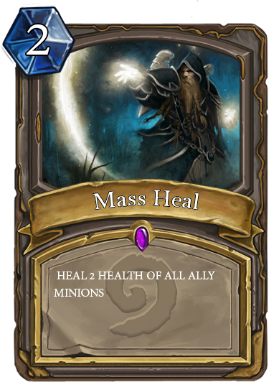

Figure 30 - Mass Heal and Framed Mass Heal with its effect

**Level 3**

**11. Poison**

This spell can be cast against the opponent’s minion only. This spell destroys the target minion and decreases the other minions health equal to the attack value of the target minion. The cost of this spell is 12 mana.

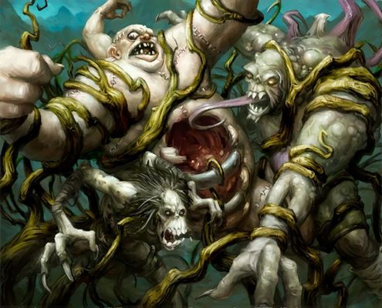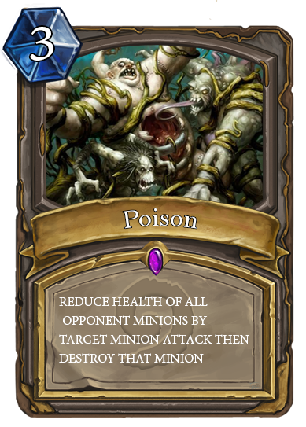

Figure 31 - Poison and Framed Poison with its effect

**12. Instant Kill**

This spell can be cast to opponent’s minion only. This spell sets the target minion health to 0. The cost of this spell is 9 mana.

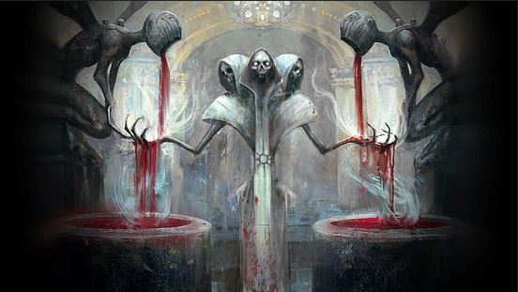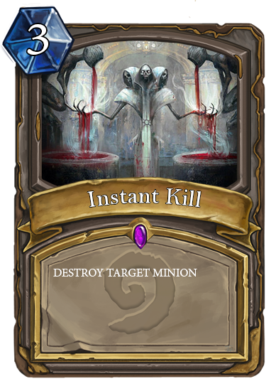

Figure 32 - Instant kill and Framed Instant Kill with its effect

**13. Doom**

This spell can be cast on the opponent’s minion only. This spell destroys all minions on the opponent field. The cost of this spell is 20 mana.

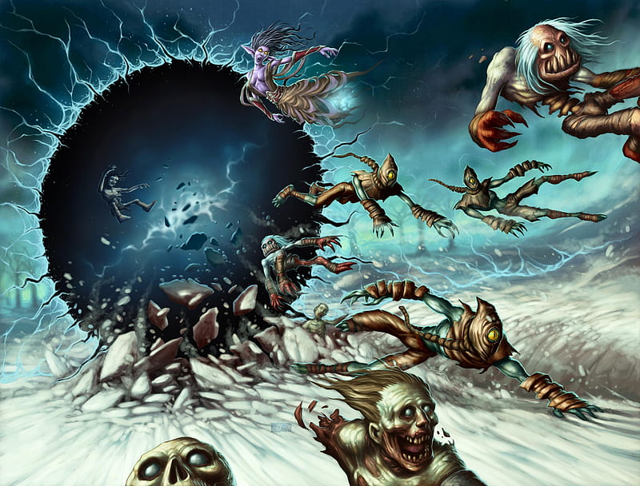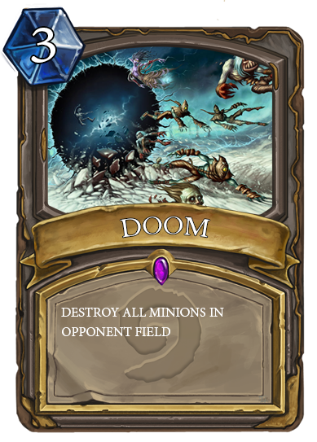

Figure 33 - Doom and Framed Doom with its effect

**14. Power Infusion**

This spell can be cast to the player minion only. This spell increases 2 attack points and 6 health points of the target minion. The cost of this spell is 8 mana.

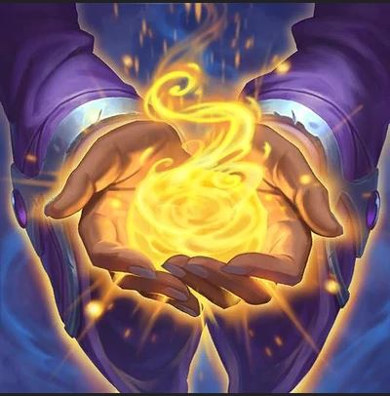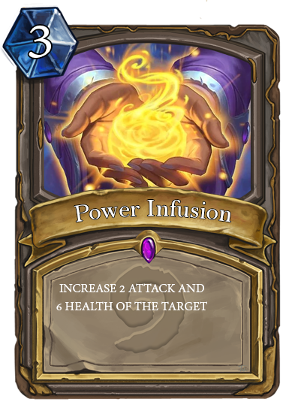

Figure 34 - Power Infusion and Framed Power Infusion with its effect

**15. Legend**

This spell can be cast directly. This spell summons dragon (12 Attack points, 12 Health points) on the player field. The cost of this spell is 12 mana.

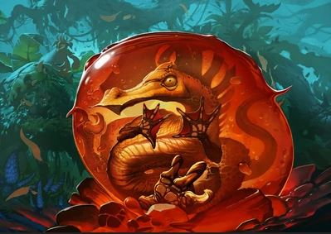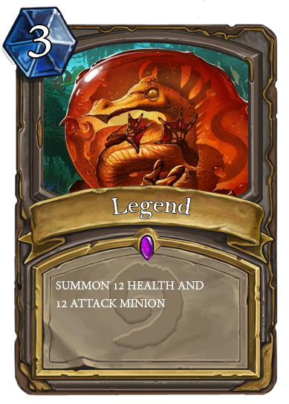

Figure 35 - Legend and Framed Legend with its effect

**Brief Gameplay**

In the game, players have to choose the hero they want to play with. Each of the heroes has different powers, health and skills.

At the start of the game, you will receive 5 mana and every turn you will receive a certain number of mana: At your turn 1-7 you will receive 2 mana per turn, turn 8-15 you will receive 4 mana per turn, for more than 15 turns you will receive 5 mana per turn. You can open the shop to buy minion and spell. In each of your turns, you can summon as many minions as you want, but you can only use either a spell or hero skill once per turn. You can press ‘brawl’ to make your minions attack your opponent minion, but if your opponent field doesn’t have any minions, you can directly attack your opponent's health. If your opponent or your health reaches zero, the game will end.

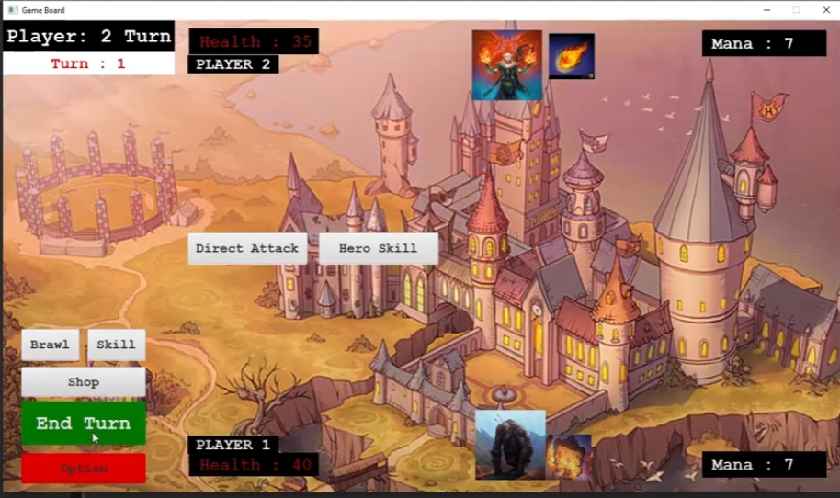

Figure 36 – GamePlay

**Game Phases**

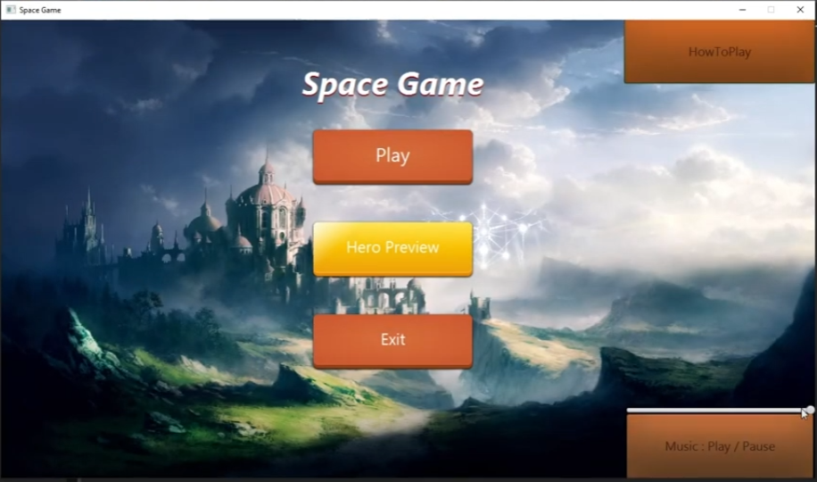

Figure 37 - Gamephases

1. At the start of the game choose your hero

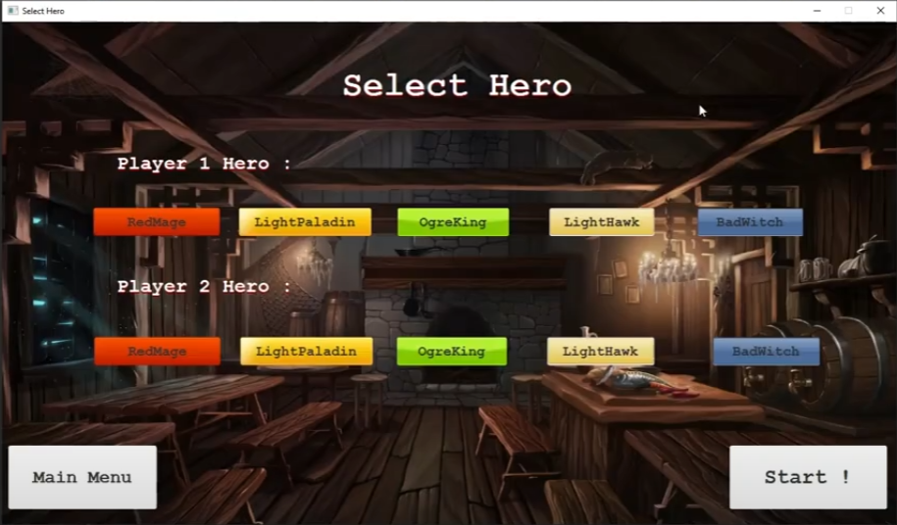

Figure 38 – Gamephases

2. Spend mana to buy minions and spells from the shop

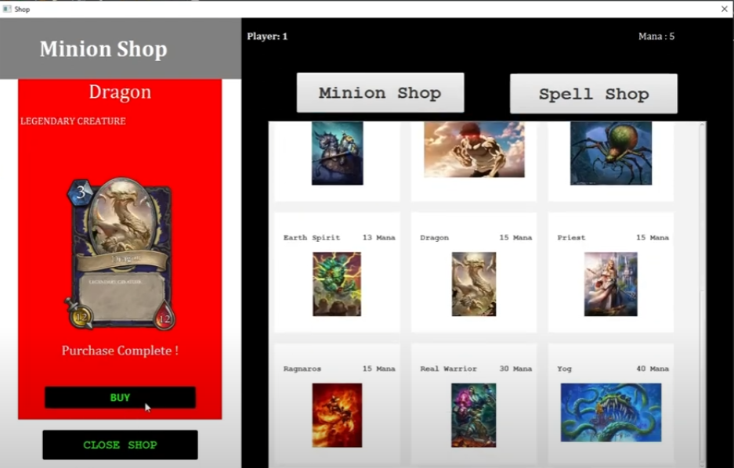

FIgure 39 - Gamephase

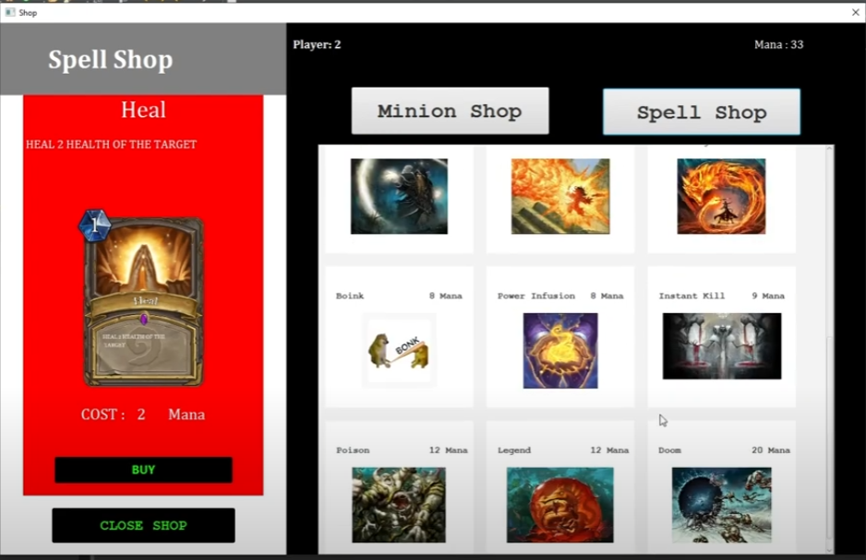

FIgure 40 - Gamephase

3. Choose to summon minion, use spell or use hero’s skill

4. Brawling between minions or attacking the opponent’s health directly

5. Repeat step 2 through 4 until one player’s health reaches 0

**Game Ending**

The game ends when one player’s health reaches 0. If one player’s health reaches 0, the alert will pop out. The alert is set to be information type. The header text will say “WE HAVE A WINNER”. The content text will say “The game result is:”, and after the “:” will say the player who wins. After that, the content text will continue with “Click ok to go back to Main Menu”.

If the ok button is clicked, both of the players will return to the Main Menu. Players can play together again like when players start the application.

**UML Class Diagram**

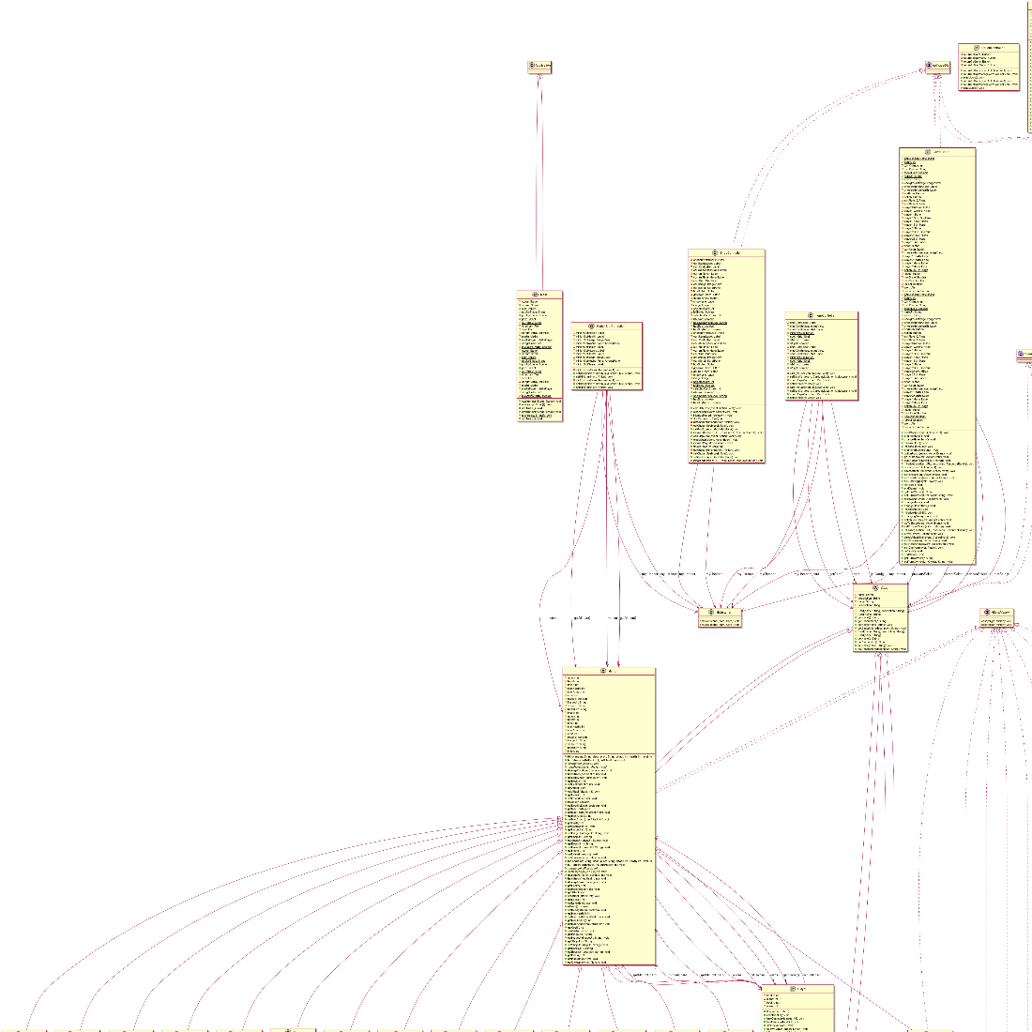

**Class Details**

Abbreviation and characters meanings

|  |  |
| --- | --- |
| **Characters** | **Meanings** |
| + | public |
| # | protected |
| - | private |
| underline | static |

**1. Package application**

**(1.1) Class Main**

This class contains the first scene of the game when the application and playing music method starts. Also, this class is used to start the game

**(1.1.1) Fields**

|  |  |
| --- | --- |
| **Name** | **Description** |
| + Stage stage | Main stage |
| + Scene scene | Main scene |
| + Parent root | Loading FXML file for main scene |
| + Stage popUpStage | Pop up stage |
| + Scene popUpScene | Pop up scene |
| + Parent pop | Loading FXML file for main pop up |
| + final String currency | Set as “ Mana” |
| + MediaPlayer mediaPlayer | Song player |
| + boolean isMusicRunning | Set as true |
| - int songNumber | Number of songs in file |
| - File directory | Store music file |
| - File[] files | Store directory as list |
| - ArrayList<File> songs | Store file |
| - Media media | Store song |

**(1.1.2) Method**

|  |  |
| --- | --- |
| **Name** | **Description** |
| + void start(Stage primaryStage) throws Exception | * Add music to application by calling addMusic() * Load Logic/MainMenu.fxml to root * Set Scene width as 1280 and height as 720 * Set stage as primaryStage * Set scene in stage * Set stage unresizeable * Set application title as “SPACESTONE” * Show stage |
| + void main(String[] args) | * Launch the game |

**2. Package Controller**

**(2.1) Class ItemController**

This class contains controller for Minion and Spell Pane in shop. It is used to set data and check type of card

**(2.1.1) Fields**

|  |  |
| --- | --- |
| **Name** | **Description** |
| - Label smallCostLabel | Import from Logic/Item.fxml |
| - ImageView smallCardImage | Import from Logic/Item.fxml |
| - Label smallCardNameLabel | Import from Logic/Item.fxml |
| + Minion minionInGrid | Store minion that is in the grid |
| + Spell spellInGrid | Store spell that is in the grid |
| - MyListener myListener | Store myListener of the method |
| + boolean isMinion | Set as false |
| + boolean isSpell | Set as false |

**(2.1.2) Method**

|  |  |
| --- | --- |
| **Name** | **Description** |
| + void setDataCard(Card card, MyListener myListener) | - Set card as card  - Set myListener as myListener  - Call checkTypeCard(card) method  - if isMinion equals to true, set smallCostLabel as “” + minionInGrid.getCost() + Main.currency, set smallCardNameLabel text as “ “ + minionInGrid.getName(), initialize image as minionInGrid image, set smallCardImage as image  - if isSpell equals to true, set smallCostLabel text as “” + spellInGrid.getCost() + Main.currency, set smallCardNameLabel text as “ “ + spellInGrid.getName(), initialize image as spellInGrid image, set smallCardImage as image |
| + void checkTypeCard(Card card) | - Loop Minion x in GameLogic.getAllMinions(), if name of minion x equals to name of card, set isMinion to true, set minionInGrid to x, set isSpell to false  - Loop Spell x in GameLogic.getAllSpells(), if name of spell x equals to name of card, set isSpell to true, set spellInGrid to x, set isMinion to false |
| + Getter and Setter for Card |  |

**(2.2) Class MinionSlotController**

This class contains controller for minion in GameBoard. When player clicks the minion, the image view will pop up in the left of the scene. This class also used to set data for minion

**(2.2.1) Fields**

|  |  |
| --- | --- |
| **Name** | **Description** |
| - Label minionSlotAttack | Import from Logic/MinionSlot.fxml |
| - Label minionSlotHealth | Import from Logic/MinionSlot.fxml |
| - ImageView minionSlotImage | Import from Logic/MinionSlot.fxml |
| - Minion minion | Store minion |
| - MyListener myListener | Store myListener for card |
| - AnchorPane minionSlotAnchorPane | Import from Logic/MinionSlot.fxml |
| - Label minionSlotName | Import from Logic/MinionSlot.fxml |

**(2.2.2) Method**

|  |  |
| --- | --- |
| **Name** | **Description** |
| - void click(MouseEvent mouseEvent) | - Call myListener.onClickListener(minion) |
| + void setData(Minion minion, MyListener myListener) | - Set minionSlotAnchorPane maxWidth to 170.  - Set minion as minion  - Set myListener as myListener  - Set minionSlotName as minion.getName()  - Set minionSlotAttack text as “ATK:” + minion.getAttack()  - Set minionSlotHealth text as “HP:” + minion.getHealth()  - Initialize image as minion image  - Set minionSlotImage image as image |
| + Getter and Setter for minion |  |

**(2.3) public interface MyListener**

This interface is called to create listener for card when clicked

**(2.3.1) Method**

|  |  |
| --- | --- |
| **Name** | **Description** |
| + void onClickListener(Card card) | - Called when user clicked card |

**(2.4) Class OptionController**

This class contains a controller for option scene.This class contains buttons that return to game, return to Main Menu and playing/pausing media.

**(2.4.1) Fields**

|  |  |
| --- | --- |
| **Name** | **Description** |
| - Button returnToGame | - Import from Logic/Option.fxml |
| - Button returnToMainMenu | - Import from Logic/Option.fxml |

**(2.4.2) Method**

|  |  |
| --- | --- |
| **Name** | **Description** |
| + returnToGame(ActionEvent event) throws IOException | - If the player presses Button called “Return To Game” in option pop up,  Logic.GameBoard.optionPopUp.close() will be called |
| + returnToMainMenu(ActionEvent event) throws IOException | - Set Logic.GameBoard.optionPopUp as returnToGame.getScene().getWindow()  - Call Logic.GameBoard.optionPopUp.close()  - Set Main.root as “Logic/MainMenu.fxml” by calling FXMLLoader.load(getClass().getClassLoader().getResource("Logic/MainMenu.fxml"))  - Initialize Main.scene as Main.root  - Set Main.stage scene as Main.scene  - Set Main.stage unresizeable  - Set Main.stage title as “SPACESTONE”  - Call Main.stage.show()  - Call Logic.GameBoard.gameBoard.refresh()  - Set Logic.GameBoard.gameBoard to null  - Set Logic.GameBoard.count to 0 |
| + playMusic() | - If the player presses the button when the music is playing, the music stops, but if the player presses the button when the music stops, the music continues.  - In code, if Main.isMusicRunning equals to true, call Main.mediaPlayer.pause() and set Main.isMusicRunning to false,  Else, call Main.mediaPlayer.play() and set Main.isMusicRunning to true |

**(2.5) Class ShopController**

This class contains controller for shop. Player needs to click the Minion Button or the Spell button to enter the specific shop. After player clicked, the list of card pane will show out in white pane. Player can buy card from clicking the card and buy it. If the player has already bought spell, The player won’t be able to buy it again. But player can buy minions in unlimited time but will be reach the limit when the size of player minion board reaches 5.

**(2.5.1) Fields**

|  |  |
| --- | --- |
| **Name** | **Description** |
| - VBox chosenMinionCard | - Import from Logic/Shop.fxml |
| - Label cardNameLabel, cardCostLabel, cardDescriptionLabel, currentPlayer, currentPlayerMana | - Import from Logic/Shop.fxml |
| - GridPane cardGrid | - Import from Logic/Shop.fxml |
| - ScrollPane cardScroll | - Import from Logic/Shop.fxml |
| - Button buyButton, goMinionShop, goSpellShop | - Import from Logic/Shop.fxml |
| - Label shopName | - Import from Logic/Shop.fxml |
| - Image image | Store image for minion or spell |
| - MyListener myListener | Store listener when click card |
| - int selectedCard | Store mana cost of selected card |
| - boolean isClicked | Set as false |
| - int selectedCardIndex | Store index of selectedCard by checking ArrayList of all spells and ArrayList of all minions. |
| + boolean isMinion | Set as false |
| + String spellNameFromShop | Set as “” |
| + boolean hasBuy | Set as false |
| + boolean hasBuyMinion | Set as false |

**(2.5.2) Method**

|  |  |
| --- | --- |
| **Name** | **Description** |
| + void calculateCost(ActionEvent event) |  |
| + void closeShop(ActionEvent event) throws IOException | - If user press the button “CLOSE SHOP”, the Main pop up stage will be closed.  - Set isClicked as false |
| + void initializePlayerInformation() | - If the game starts, set currentPlayer text as “Waiting for game to start”, set currentPlayerMana text as “0” and set cardCostLabel text as “Please start the game first”  - When the game continues, if GameBoard.count %2 equals to 1, set currentPlayer text as “Player: 1” and set currentPlayerMana text as “Mana : ” + GameLogic.PlayerOne.getMana(). if GameBoard.count %2 equals to 0, set currentPlayer text as “Player: 2” and set currentPlayerMana text as “Mana : ” + GameLogic.PlayerTwo.getMana(). |
| + int findCard(Card card) | - Loop i GameLogic.getAllMinions().size() by starting at 0  - if card name equals to GameLogic.getAllMinions().get(i).getName(), return index  - Loop i GameLogic.getAllSpells().size() by starting at 0  - if card name equals to GameLogic.getSpellMinions().get(i).getName(), return index |
| - void setChosenMinion(Minion minion) | - Set cardNumber text as minion.getName()  - Set cardDescriptionLabel text as minion.getDescription()  - Set cardCostLabel text as “COST : \t” plus minion.getCost() plus Main.currency  - Set selectedCard as minion.getCost  - Set selectedCardIndex as findCard((card) minion)  - Set isMinion as true  - Set image as spellImage  - Set cardImage Image as image |
| - void setChosenSpell(Spell spell) | - Set cardNameLabel text as spell.getName()  - Set cardDescriptionLabel text as spell.getDescription()  - Set cardCostLabel text as “COST : \t” plus spell.getCost() plus “\t” plus Main.currency  - Set selectedCard as spell.getCost()  - Set selectedCardIndex = findCard((Card) spell)  - Set isMinion as false  - Set image as spellImage  - Set cardImage Image as image |
| + void setGridSize(GridPane cardGrid) | - Set cardGrid MinWidth as Region.USE_COMPUTED_SIZE  - Set cardGrid PrefWidth as Region.USE_COMPUTED_SIZE  - Set cardGrid MaxWidth as  Region.USE_PREF_SIZE  - Set cardGrid MinHeight as Region.USE_COMPUTED_SIZE  - Set cardGrid PrefHeight as Region.USE_COMPUTED_SIZE  - Set cardGrid MaxHeight as Region.USE_PREF_SIZE |
| + void initialize(URL location,  ResourceBundle resources) | - Initialize minions as new ArrayList  - Initialize spells as new ArrayList  - Add all minions to minions ArrayList by calling minions.addAll(GameLogic.getAllMinions())  - Add all spells to spells ArrayList by calling  spells.addAll(GameLogic.getAllSpells())  - Set shopName text as “Card Shop”  - Call setChosenMinion(minions.get(0))  - Set onMouseClicked to goMinionShop button  - onMouseClicked handle method contains these. Set isClicked to true, Call initializePlayerInformation(), set shopName text as “Minion Shop”, call setChosenMinion(minion.get(0)). Initialize myListener by override onClickListener(Card card). In onClickListener, call ItemController.checkTypeCard(card), call setChosenMinion(ItemController.minionInGrid)  After finish overriding, initialize column and row to 0 and 1 in order. Loop index in minions by starting at 0. Initialize fxmlLoader and set its location to “Logic/Item.fxml” by calling fxmlLoader.setLocation(getClass().getClassLoader().getResource("Logic/Item.fxml"))  Do try/catch. In try, Initialize AnchorPane anchorpane and load it by using fxmlLoader.load(). Initialize itemController by fxmlLoader.getController(). Call itemController.setDataCard((Card) minions.get(i), myListener). Check if (column equals to 3, if so, set column to 0 and increase row by 1. Call cardGrid.add(anchorPane, column++,row). Call setGridSize(cardGrid) and call gridPane.setMargin(achorPane, new Insets(10))  Catch IOException e, if catch, call e.printStackTrace()  - Set onMouseClicked to goSpellShop  - In onMouseClicked listener, Set isClicked to true, Call initializePlayerInformation(), set shopName text as “Spell Shop”, call setChosenSpell(spells.get(0)). Initialize myListener by override onClickListener(Card card). In onClickListener, call ItemController.checkTypeCard(card), call setChosenSpell(ItemController.spellInGrid)  After finish overriding, initialize column and row to 0 and 1 in order. Loop index in spells by starting at 0. Initialize fxmlLoader and set its location to “Logic/Item.fxml” by calling fxmlLoader.setLocation(getClass().getClassLoader().getResource("Logic/Item.fxml"))  Do try/catch. In try, Initialize AnchorPane anchorpane and load it by using fxmlLoader.load(). Initialize itemController by fxmlLoader.getController(). Call itemController.setDataCard((Card) spells.get(i), myListener). Check if (column equals to 3, if so, set column to 0 and increase row by 1. Call cardGrid.add(anchorPane, column++,row). Call setGridSize(cardGrid) and call gridPane.setMargin(achorPane, new Insets(10)) |

**3. Package Interface**

**(3.1) public interface AttackMinion**

This interface shows that spell can attack a minion.

**(3.1.1) Method**

|  |  |
| --- | --- |
| **Name** | **Description** |
| + void cast(Minion target) | Called when spell is casted to attack minion |

**(3.2) public interface BuffMinion**

This interface shows that spell can increase minion stats.

**(3.2.1) Method**

|  |  |
| --- | --- |
| **Name** | **Description** |
| + void cast(Minion target) | Called when spell is casted to increase minion stats. |

**(3.3) public interface SpawnMinion**

This interface shows that spell can spawn a minion.

**(3.3.1) Method**

|  |  |
| --- | --- |
| **Name** | **Description** |
| + void cast() | Called when spell is casted when player wants to spawn a minion to their board |

**4. Package Logic**

**(4.1) Class GameBoard**

This class contains most of the game controller. The game can be run smoothly by this class.

**(4.1.1) Fields**

|  |  |
| --- | --- |
| **Name** | **Description** |
| + GameBoard gameBoard | Store every field and methods in gameboard for checking in other classes |
| + int count | Set as 0 |
| - int turnChange | Set as 1 |
| - String turnOwner | Set as false |
| + boolean stopMusic | Set as false |
| + String heroUrl | Set as “Card/Hero/” |
| + String skillUrl | Set as “pic/” |
| - Card currentSelect | Set as null |
| - Card previousSelect | Set as null |
| - ImageView backgroundImage | Import from Logic/GameBoard.fxml |
| - Label chosenMinionAttack | Import from Logic/GameBoard.fxml |
| - Label chosenMinionHealth | Import from Logic/GameBoard.fxml |
| - Button endTurn | Import from Logic/GameBoard.fxml |
| - Button option | Import from Logic/GameBoard.fxml |
| - Pane skillPlayer1 | Import from Logic/GameBoard.fxml |
| - Pane skillPlayer2 | Import from Logic/GameBoard.fxml |
| - HBox playerOneBox | Import from Logic/GameBoard.fxml |
| - HBox playerTwoBox | Import from Logic/GameBoard.fxml |
| - Pane palyer1 | Import from Logic/GameBoard.fxml |
| - GridPane player1Grid | Import from Logic/GameBoard.fxml |
| - HBox player1Hbox | Import from Logic/GameBoard.fxml |
| - Pane player1Skill | Import from Logic/GameBoard.fxml |
| - Pane player2 | Import from Logic/GameBoard.fxml |
| - GridPane player2Grid | Import from Logic/GameBoard.fxml |
| - HBox player2Hbox | Import from Logic/GameBoard.fxml |
| - Pane player2Skill | Import from Logic/GameBoard.fxml |
| - Label playerTurn | Import from Logic/GameBoard.fxml |
| - Button shop | Import from Logic/GameBoard.fxml |
| - Label turnCount | Import from Logic/GameBoard.fxml |
| - ImageView chosenMinionImage | Import from Logic/GameBoard.fxml |
| - Label player1Health | Import from Logic/GameBoard.fxml |
| - Label player2Health | Import from Logic/GameBoard.fxml |
| - Label player1Mana | Import from Logic/GameBoard.fxml |
| - Label player2Mana | Import from Logic/GameBoard.fxml |
| + Stage optionPopUp | Stage for option when user click option button |
| - Pane MinionPane | Import from Logic/GameBoard.fxml |
| - Image image | Store backgroud image |
| - MyListener myListener | Store myListener for Card |
| - boolean hasBrawl | Set as false |
| + boolean hasCast | Set as false |
| - boolean isHeal | Set as false |
| - Alert alert | Set alert type as Error |

**(4.1.2) Methods**

|  |  |
| --- | --- |
| **Name** | **Description** |
| + void startGame(ActionEvent event) throws IOException | - If the game starts, set player one mana and player two mana as 5. Set playerTurn text as “Player: 1 Turn”, set TurnOwner as “Player1”, set turnCount as “Turn == 1”  - increase count, turnchange by 1 every time the player press the endTurn button.  - call changingBackground method  - call changeMana method  - if the player presses the Start button, set endTurn text as “End Turn”  - call initializeHero method  - call initializeHeroSkill method  - set player 1 hero as selected player 1 hero from SceneController class  - set player 2 hero as selected player 2 hero from SceneController class  - Every time player ends turn, set hasCast to false  , set hasBrawl to false, set ShopController.hasBuy to false, set ShopController.hasBuyMinon to false  - call changePlayerTurn method  - call refresh method |
| + void changeMana() | - If the game starts, set playerOne mana as 7 and set playerTwo mana as 5  - set player1Mana text as “ Mana : “ + player one mana  - set player2Mana text as “ Mana : ” + player two mana  - after the game start, every time the player turn has come, increase mana player as 2 every round. When the turn reach 8, the player will get 4 mana every round. After the player reach turn 16, the player will get 5 mana every round and will keep this pace forever until one player health reaches 0.  - set player1Mana and player2Mana text as “ Mana : “ + the player mana after the player end turn to show the player remaining mana. |
| + void changePlayerTurn() | If count % 2 equals to 1, set playerTurn text as “Player: 1 turn” and set turnOwner as “Player1” otherwise, set playerTurn text as “Player: 2 turn” and set turnOwner as “Player2” |
| + void initializeHero() | - Set selectedHero1 imageView as player 1 hero  - Set selectedHero2 imageView as player 2 hero  - set selectedHero1 and selectedHero2 Fit Width as 107  - set selectedHero1 and selectedHero2 Fit Height as 107  - add selectedHero1 to player1.  - add selectedHero2 to player2.  - set player1Health text as “ Health : ” + player 1 hero health.  - set player2Health text as “ Health : ” + player 2 hero health. |
| + void initializeHeroSkill() | - Set selectedSkill1 image as player 1 hero power  - Set selectedSkill2 image as player 2 hero power  - Set selectedSkill1 and selectedSkill2 FitWidth and FitHeight to 70 and 70 in order.  - Add selectedSkill1 to player1Skill  - Add selectedSkill2 to player2Skill |
| + void changingBackground() | - if count % 3 equals to 2, set the image as gameBoard1.jpg  - If count % 3 equals to 1, set the image as gameBoard2.jpg  - Otherwise set the image as gameBoard3.jpg  - Set the backGroundImage as image |
| + void optionPopUp(ActionEvent event) throws IOException | - Initialzie optionPopUp as new stage  - Set Main.pop as Shop.fxml  - Set Main.popUpStage scene as Main.pop  - Set Main.popUpStage modality as Modaily.APPLICATION_MODAL  - Set Main.popUpStage owner to Main.Stage  - Set Main.popUpStage resizeable to false  - set Main.popUpStage title as “Shop”  - Call showAndWait for Main.popUpStage |
| - void setChosenMinion(Minion minion) | - Set player to the player that returns from calling GameLogic.checkPlayer method  - if the player is GameLogic.playerOne, set GameLogic.indexPlayerOne to the minion index otherwise set GameLogic.indexPlayerTwo to the minion index  - Set the image as minion picture  - Set chosenMinionImage as image  - Set chosenMinionAttack text as minion attack  - Set chosenMinionHealth text as minion health |
| + void initialize(Url location, ResourceBundle resources) | - clear player1Grid and player2Grid  - if gameBoard equals to null, set gameBoard to this |
| + void brawl(ActionEvent event) throws IOException | - Set player to the player that returns from calling GameLogic.checkPlayer method  - Set alert title as “Warning”  - if previousSelect equals to null, set Alert HeaderText as “Please select Minion to brawl” and call showAndWait() method  - else if previousSelect owner equals to currentSelect owner, set alert HeaderText as “Please choose new target” and call showAndWait() method  - else if previousSelect owner is not equal to player, set alert HeaderText to “Please choose minion on your side” and call showAndWait() method  - else if hasBrawl equals to false, if player is equals to GameLogic.playerOne, set GameLogic.indexPlayerOne to the previousSelect index and set GameLogic.indexPlayerTwo to the currentSelect index. if the player is equals to GameLogic.playerTwo, set GameLogic.indexPlayerTwo to the previousSelect index and set GameLogic.indexPlayerOne to the currentSelect index. Call GameLogic.minionAction() and set hasBrawl to true. Call refresh() method  - otherwise, set alert HeaderText to “You have brawled already” and call showAndWait() method |
| + void directAttackSkill(ActionEvent event) throws IOException | - Set boolean hasPass to false  - if count > 0, set player as the player that returns from calling GameLogic.checkPlayer() method  ,set alert title as “Warning”  -- if hasBrawl equals to false |
| + void skillShop(ActionEvent event) throws IOException | - If shopController.hasBuy equals to true and ShopController.isMinion equals to false, set player as return player in GameLogic.checkPlayer(), set alert titlte to “Warning”, if GameLogic.getVoidSpells().contains(ShopController.spellNameFromShop), call skillCasting(player) method , otherwise, if currentSelect equals to null, set alertHeaderText to “Please choose minion to cast your hero skill to” , else if ShopController.spellNameFromShop equals to “Heal”, check whether currentSelect owner is not equals to player, if the currentSelect owner is not equals to player, set alert HeaderText as “Please choose minion on your side”, otherwise, set isHeal to true  - After checking that currentSelect equals to null or not, call skillCasting(player) method |
| + void skillHeroAttack(ActionEvent event) throws IOException | - If count is more than 0, set player as returned player from GameLogic.checkPlayer(), set alert title as “Warning”, if the name of hero power equals to “Quick Recruit”, call skillCasting(player) method, otherwise check if currentSelect equals to null, if so, set alert HeaderText as “Please choose minion to cast your hero skill to”, and call showAndWait() method  If the hero power name equals to “Heal”, check that currentSelect owner equals to player or not, if not, set alert HeaderText to “Please choose minion on your side” and call showAndWait() method, if so, set isHeal to true  After finish checking owner of currentSelect, call skillCasting(player) method.  If currentSelect doesn’t equal to null, call skillCasting(player) method  - if count equals to 0, set alert HeaderText as “Please start the game first” and call showAndWait() method |
| + void skillCasting(Player player) | - If hasCast equals to false, set voidSpells as ArrayList that return from Gamelogic.getVoidSpells() method, if the name of player hero power equals to “Quick Recruit” or ShopController.spellNameFromShop is contained in voidSpells, check if (ShopController.hasBuy equals to true && player hero power name isn’t equal to “Quick Recruit”, if pass, call GameLogic.spellAction(ShopController.spellNameFromShop) method, set ShopController.hasBuy to false and set hasCast to true. If not pass, check if ShopController.hasBuy equals to true && player hero power name equals to “Quick Recruit”, if the condition pass, call GameLogic.spellAction(ShopController.spellNameFromShop), set ShopController.hasBuy to false, set hasCast to true, if still not pass, check if hasCast equals to false, if pass, call GameLogic.spellAction(player.getHero().getPower().getName())  After finish checking the name of player hero power equals to “Quick Recruit” or ShopController.spellNameFromShop is contained in voidSpells condition , set hasCast to true and call refresh() method  - if the name of player hero power equals to “Quick Recruit” or ShopController.spellNameFromShop is contained in voidSpells condition is not passed, check if hero player name equals to “Inner Rage” or ShopController.spellNameFromShop equals to “Inner Rage”, if so, set GameLogic.indexPlayerOne to currentSelect index and set GameLogic.indexPlayerTwo to currentSelect. If not, check if player equals to GameLogic.playerOne, check if isHeal equals to true, if so, set GameLogic.indexPlayerOne to currentSelect index if isHeal is false, set GameLogic.indexPlayerTwo to currentSelect index. If the player is not equals to GameLogic.playerOne but equals to GameLogic.playetTwo instead, check if isHeal is true or not, if it’s true, set GameLogic.indexPlayerTwo to currentSelect index, if isHeal is false, set GameLogic.playerOne to currentSelect index.  - After checking the player, check if ShopController.hasBuy equals to true && ShopController.spellNameFromShop length is more than 0, if so, call GameLogic.spellAction(ShopController.spellNameFromShop) method and set ShopController.hasBuy to false. If not, call GameLogic.spellAction(player.getHero().getPower().getName())  After finish checking the ShopController.hasBuy equals to true && ShopController.spellNameFromShop length is more than 0 condition, set hasCast to true and call refresh() method  - if hasCast, set alert HeaderText to “You have use your skill already” and call showAndWait() method. |
| + void refresh() throws IOException | - Clear player1Grid and player2Grid  - Set myListener as new MyListener() method by casting onClickListener(Card card) .The method contains these. if currentSelect equals to null, set currentSelect to card. Set previousSelect to currentSelect. Set currentSelect to card and cast setChosenMinion((Minion) card) method  - After finish writing myListener method, declare c as int variable and set it to 0.  - Call GameLogic.playerOne.setIndexMinion() method  - After this, it will be how to refresh player 1 and player 2 board.  -  - To refresh player 1 board, check each index by looping GameLogic.playerOne.getMinionBoard().size(), initialize fxmlLoader, set fxmlLoader location as “Logic/Minion”. Do try catch. In try, set AnchorPane anchorPane as fxml.load(), set MinionSlotController itemController to fxmlLoader.getController(), if (GameLogic.playerOne.getMinionBoard.get(i).getHealth() > 0), set data to itemController by calling itemController.setData(GameLogic.playerOne.getMinionBoard().get(i), myListener) method, call player1Grid.add(anchorPane, c++, 1) method, call ShopController.setGridSize(player1Grid), call GridPane.setMargin(anchorPane, new Insets(10))  catch IOException e, if can catch, call e.printStackTrace() to print error out to console  - To refresh player 2 board, check each index by looping GameLogic.playerTwo.getMinionBoard().size(), initialize fxmlLoader, set fxmlLoader location as “Logic/Minion”. Do try catch. In try, set AnchorPane anchorPane as fxml.load(), set MinionSlotController itemController to fxmlLoader.getController(), if (GameLogic.playerTwo.getMinionBoard.get(i).getHealth() > 0), set data to itemController by calling itemController.setData(GameLogic.playerTwo.getMinionBoard().get(i), myListener) method, call player2Grid.add(anchorPane, c++, 1) method, call ShopController.setGridSize(player2Grid), call GridPane.setMargin(anchorPane, new Insets(10))  catch IOException e, if can catch, call e.printStackTrace() to print error out to console  - After finishing refresh player 1 and player 2 board, set player1Mana and player2Mana text as “ Mana : ” + GameLogic.playerOne.getMana() for player1Mana and + GameLogicplayerTwo.getMana() for player2Mana  - Set player1Health and player2Health text as “ Health : ” + GameLogic.playerOne.getHealth() for player1Health and + GameLogic.playerTwo.getHealth() for player2Health  - If GameLogic.playerOne.getHealth equals to 0 or GameLogic.playerTwo.getHealth equals to 0, call endGame() method |
| + void endGame() throws IOException | - Set gameResult as “”  - if GameLogic.playerOne.getHealth() equals to 0  Set gameResult to “PLAYER 2 WINS!” , if GameLogic.playerTwo.getHealth() equals to 0, Set gameResult to “PLAYER 1 WINS!”  - Set dialogueString as “The game result is ” + gameResult + “\n\nClick ok to go back to Main Menu”  - Initialize alert by setting its type as AlertType.INFORMATION  - Set alert title as “Game has Ended!”  - Set alert HeaderText as “WE HAVE A WINNER!”  - Set alert ContentText as dialogueString  - Set Optional<ButtonType> result as alertEnd.showAndWait() method  - if result.get() equals to ButtonType.OK, Set Main.root as Logic/MainMenu.fxml by calling FXMLLoader.load(getClass().getClassLoader().getResource("Logic/MainMenu.fxml")) method,  set Main.scene as new Scene from Main.root, set scene for Main.stage scene as Main.Scene, set Main.stage resizeable to false, set Main.stage title as “SPACESTONE”, call Main.stage.show(), set Logic.GameBoard.count to 0, clear player1Grid and player2Grid |
| + Getter and Setter for turnOwner |  |

**(4.1.3) Method**

|  |  |
| --- | --- |
| **Name** | **Description** |
| + String getName() |  |

**(4.2) Class GameLogic**

This class contains logic that other classes use. Attacking and Casting spell are also contained in this class

**(4.2.1) Fields**

|  |  |
| --- | --- |
| **Name** | **Description** |
| + Player playerOne | Initialize as Player(SceneController.hero1) |
| + Player playerTwo | Initialize as Player(SceneController.hero2) |
| + int indexPlayerOne | Store index of minion in player one field |
| + int indexPlayerTwo | Store index of minion in player two field |

**(4.2.2) Methods**

|  |  |
| --- | --- |
| **Name** | **Description** |
| + Player checkPlayer() | If Gameboard.count divided by 2, the remainder is 1. It becomes Player1’s turn, but if it isn’t, it becomes Player2’s turn. |
| + ArrayList<Minion> getLevelOneMinions() | - Add Dog, FireSpirit, Gobuta, Spider and Georde in order in the ArrayList. Will return an ArrayList containing minions we added previously. |
| + ArrayList<Minion> getLevelTwoMinions() | - Add Hobgoblin, Knight, MuscleDude, SpiderCave and EarthSpirit in order in the Arraylist. Will return an Arraylist containing minions we added previously. |
| + ArrayList<Spell>getLevelOneSpells() | - Add Heal, Fireblast, Innerrage, Buff and Quickrecruit in order in the Arraylist. Will return an Arraylist containing spells we added previously. |
| + ArrayList<Spell>getLevelTwoSpells() | - Add Bindingheal, Massheal, Fireball, Firerings and Boink in order in the Arraylist. Will return an Arraylist containing spells we added previously. |
| + ArrayList<Spell>getLevelThreeSpells() | - Add Powerinfusion, Instantkill, Poision, Legend and Doom in order in the Arraylist. Will return an Arraylist containing spells we added previously. |
| + ArrayList<Minion> getAllMinions() | - Initialize the Minion ArrayList  - Added LevelOneMinions ArrayList, LevelTwoMinions ArrayList, and LevelThreeMinions ArrayList to the Minion Arraylist.  - Return the ArrayList that contained LevelOneMinions, LevelTwoMinions and LevelThreeMinions ArrayList. |
| + ArrayList<Spell> getAllSpells() | - Initialize the Spell ArrayList  - Added LevelOneSpells ArrayList, LevelTwoSpells ArrayList, and LevelThreeMSpells ArrayList to the Spell Arraylist.  - Return the ArrayList that contained LevelOneSpells, LevelTwoSpells and LevelThreeSpells ArrayList. |
| + ArrayList<String> getBuffSpells() | - Initialize the BuffSpell ArrayList  - add Spell’s name, which has Buff, heal, Bindingheal, Massheal, Powerinfusion and Innerrage to the BuffSpell Arraylist.  - Return the Arraylist that contained Spell’s name, which has Buff, heal, Bindingheal, Massheal, Powerinfusion and Innerrage to the BuffSpell Arraylist. |
| + ArrayList<String> getVoidSpells() | - initialize the VoidSpell ArrayList  - add Spell’s name, which has Quickrecruit, Legend and Boink to the VoidSpell Arraylist.  - Return the ArrayList that contained Spell’s name, which has Quickrecruit, Legend and Boink to the VoidSpell Arraylist. |
| + SpellAction(String name) | - Initialize player as return of checkPlayer() method  - Initialize buffSpells and voidSpells by calling getBuffSpells() and getVoidSpells() in order.  - Loop Spell spell in getAllspells(), if name of spell equals to name, if so, check if player equals to playerOne  If player equals to playerOne check if spell name is contained in buffSpells, if so, check if player minion board is empty or not. If the player minion board is not empty, Initialize healMinion as player.getMinionBoard().get(indexPlayerOne)check if spell has BuffMinion interface, if so, cast BuffMinion to spell and cast it to healMinion. If not, check if playerTwo.getMinionBoard().size() equals to 0. If so, cast AttackMinion to spell and use cast method to healMinion. If not, declare targetMinion as playerTwo.getMinionBoard().get(indexPlayerTwo), Cast AttackMinion to spell and use cast method to targetMinion  If player.getMinionBoard.size() is equals to 0, set GameBoard.hasCast to false and make alert as new alert that is Error type.  Set alert title as “Warning” and set its HeaderText as “You must have minion” and call alert.showAndWait() method in the final  If name of spell is contained in voidSpells, check if spell has SpawnMinion interface. If so, cast SpawnMinion to spell and cast it directly. If not, declare boink and cast it.  If name of spell isn’t contained in voidSpells and buffSpells, declare target as playerTwo.getMinionBoard().get(indexPlayerTwo) and cast AttackMinion to spell and use cast method to target.  If player equals to playerTwo check if spell name is contained in buffSpells, if so, check if player minion board is empty or not. If the player minion board is not empty, Initialize healMinion as player.getMinionBoard().get(indexPlayerTwo)check if spell has BuffMinion interface, if so, cast BuffMinion to spell and cast it to healMinion. If not, check if playerOne.getMinionBoard().size() equals to 0. If so, cast AttackMinion to spell and use cast method to healMinion. If not, declare targetMinion as playerTwo.getMinionBoard().get(indexPlayerOne), Cast AttackMinion to spell and use cast method to targetMinion  If player.getMinionBoard.size() is equals to 0, set GameBoard.hasCast to false and make alert as new alert that is Error type.  Set alert title as “Warning” and set its HeaderText as “You must have minion” and call alert.showAndWait() method in the final  If name of spell is contained in voidSpells, check if spell has SpawnMinion interface. If so, cast SpawnMinion to spell and cast it directly. If not, declare boink and cast it.  If name of spell isn’t contained in voidSpells and buffSpells, declare target as playerOne.getMinionBoard().get(indexPlayerOne) and cast AttackMinion to spell and use cast method to target. |
| + void MinionAction() | - If Logic.GameBoard.count is divided by 2 and the remainder is 1. It becomes Player1's turn  - Set player1Minion as playerOne.getMinionBoard().get(indexPlayerOne) and set target as playerTwo.getMinionBoard().get(indexPlayerTwo)  -If playerTwo.getMinionBoard().size() is greater than 0, the minions attack the opposing minions, but if not, the minions attack the opposing player  If Logic.GameBoard.count is divided by 2 and the remainder is 0. It becomes Player2’s turn  - Set player2Minion as playerTwo.getMinionBoard().get(indexPlayerTwo) and set target as playerOne.getMinionBoard().get(indexPlayerOne)  -If playerOne.getMinionBoard().size() is greater than 0, the minions attack the opposing minions, but if not, the minions attack the opposing player |

**(4.3) SceneController class**

This class contains Main Menu, Hero Preview, How to Play and Select hero controller. In the Main Menu, there will be a hero preview button, how to play button, exit button and play the game button. After the player clicked the play Button. The scene will change to select hero scene so both of the players can choose hero and start the game after finish choosing.

**(4.3.1) Field**

|  |  |
| --- | --- |
| **Name** | **Description** |
| + Hero hero1 | Store player one hero |
| + Hero hero2 | Store player two hero |
| - Button toPlayBtn, BackToMain, heroPreview, playButton | - Import from Logic/SelectHero.fxml and Logic/MainMenu.fxml |
| - Label redMage, lightPaladin, ogreKing, lightHawk, badWhich, redMage1, lightPaladin1, ogreKing1, lightHawk1, badWhich1 | - Import from Logic/SelectHero.fxml |
| - Label chooseHeroPlayer1. chooseHeroPlayer2 | - Import from Logic/SelectHero.fxml |
| - Slider VolumeSlider | - Initialize Slider |

**(4.3.2) Methods**

|  |  |
| --- | --- |
| **Name** | **Description** |
| + switchToSelectHero(ActionEvent event) throws IOException, InterrupptedException | - Set Main.root as FXMLLoader.load(getClass().getClassLoader().getResource("Logic/SelectHero.fxml"))  - Set Main.stage as (Stage) ((Node) event.getSource()).getScene().getWindow()  - Initialize Main.scene as scene from Main.root  - Set Main.stage scene as Main.scene  - Set Main.Stage unresizeable  - Set Main.Stage title as “Select Hero”  - Call Main.stage.show() |
| + switchToMainMenu(ActionEvent event) throws IOException | - Set Main.root as FXMLLoader.load(getClass().getClassLoader().getResource("Logic/MainMenu.fxml"))  - Set Main.stage as (Stage) ((Node) event.getSource()).getScene().getWindow()  - Initialize Main.scene as scene from Main.root  - Set Main.stage scene as Main.scene  - Set Main.Stage unresizeable  - Set Main.Stage title as “Main Menu”  - Call Main.stage.show() |
| + switchToGameBoard(ActionEvent event) throws IOException | - Set Main.root as “Logic/GameBoard.fxml” by calling FXMLLoader.load(getClass().getClassLoader().getResource("Logic/GameBoard.fxml"))  - Set Main.stage as (Stage) ((Node) event.getSource()).getScene().getWindow()  - declare boolean canPass as true  If chooseHeroPlayer1.getText().length() < 1, set chooseHeroPlayer1Text as “Player 1 please choose Hero” and set canPass to false  If chooseHeroPlayer2.getText().length() < 1,  Set chooseHeroPlayer2Text as “Player 2 please choose Hero” and set canPass to false  If canPass and chooseHeroPlayer2.getText().length() not equals to 27 and chooseHeroPlayer1.getText().length() not equals to 27, Initialize Main.scene as Main.root, set Main.stage scene as Main.scene, set Main.stage unresizeable, set Main.stage unresizeable, set Main.stage title as “Game Board” and call Main.stage.show()  After show the stage, initialize GameLogic.playerOne and GameLogic.playerTwo minionBoard as new board. Set GameLogic.playerOne hero and GameLogic.playerTwo hero as hero1 and hero2 in order. Reset GameLogic.playerOne health and GameLogic.playerTwo health. And finally call GameBoard.gameBoard.refresh() |
| + Exit(ActionEvent event) throws IOException | - Set Main.root as FXMLLoader.load(getClass().getClassLoader().getResource("Logic/MainMenu.fxml"))  - Set Main.stage as (Stage) ((Node) event.getSource()).getScene().getWindow()  - Call Main.stage.close() |
| + showHeroPreview(ActionEvent event) throws IOException | - Initialize Main.popUpStage  - Set Main.pop as FXMLLoader.load(getClass().getClassLoader().getResource("Logic/HeroPreview.fxml"))  - Set Main.popUpStage scene as Main.pop  - Init Main.popUpStage modality to Modality.APPLICATION_MODAL  - Call Main.popUpStage.initOwner(Main.stage)  - Set Main.popUpStage unresizeable  - Set Main.popUpStage title as “HeroPreview”  - Call Main.stage.showAndWait() |
| + showHowToPlay(ActionEvent event) throws IOException | - Initialize Main.popUpStage  - Set Main.pop as FXMLLoader.load(getClass().getClassLoader().getResource("Logic/HowToPlay.fxml"))  - Set Main.popUpStage scene as Main.pop  - Init Main.popUpStage modality to Modality.APPLICATION_MODAL  - Call Main.popUpStage.initOwner(Main.stage)  - Set Main.popUpStage unresizeable  - Set Main.popUpStage title as “HowToPlay”  - Call Main.stage.showAndWait() |
| + backToMain(ActionEvent event) throws IOException | - Set Main.popUpStage as (Stage) backToMain.getScene().getWindow();  - Call Main.popUpStage.close() |
| + chooseHeroForPlayerOne(ActionEvent event1) throws IOException | - If player one click Red Mage, initialize hero1 as RedMage  - If player one click Light Paladin, initialize hero1 as LightPaladin  - If player one click Ogre King, initialize hero1 as OgreKing  - If player one click Light Hawk, initialize hero1 as LightHawk  - If player one click Bad Witch, initialize hero1 as BadWitch |
| + chooseHeroForPlayerTwo(ActionEvent event2) throws IOException | - Same as chooseHeroForPlayerOne method but initialize hero2 instead |
| + initialize(URL arg0, ResourceBundle arg1) | - Add listener to volumeSlider.valueProperty() by override public void changed(ObservableValue<? extends Number> arg0, Number arg1, Number arg2)  - In changed method, call Main.mediaPlayer.setVolume(volumeSlider.getValue() * 0.01) |
| + void playMedia() | - If the player presses the button when the music is playing, the music stops, but if the player presses the button when the music stops, the music continues.  - In code, if Main.isMusicRunning equals to true, call Main.mediaPlayer.pause() and set Main.isMusicRunning to false,  Else, call Main.mediaPlayer.play() and set Main.isMusicRunning to true |

(4.4) Item.fxml

This type of file shows Item pane that shows in shop

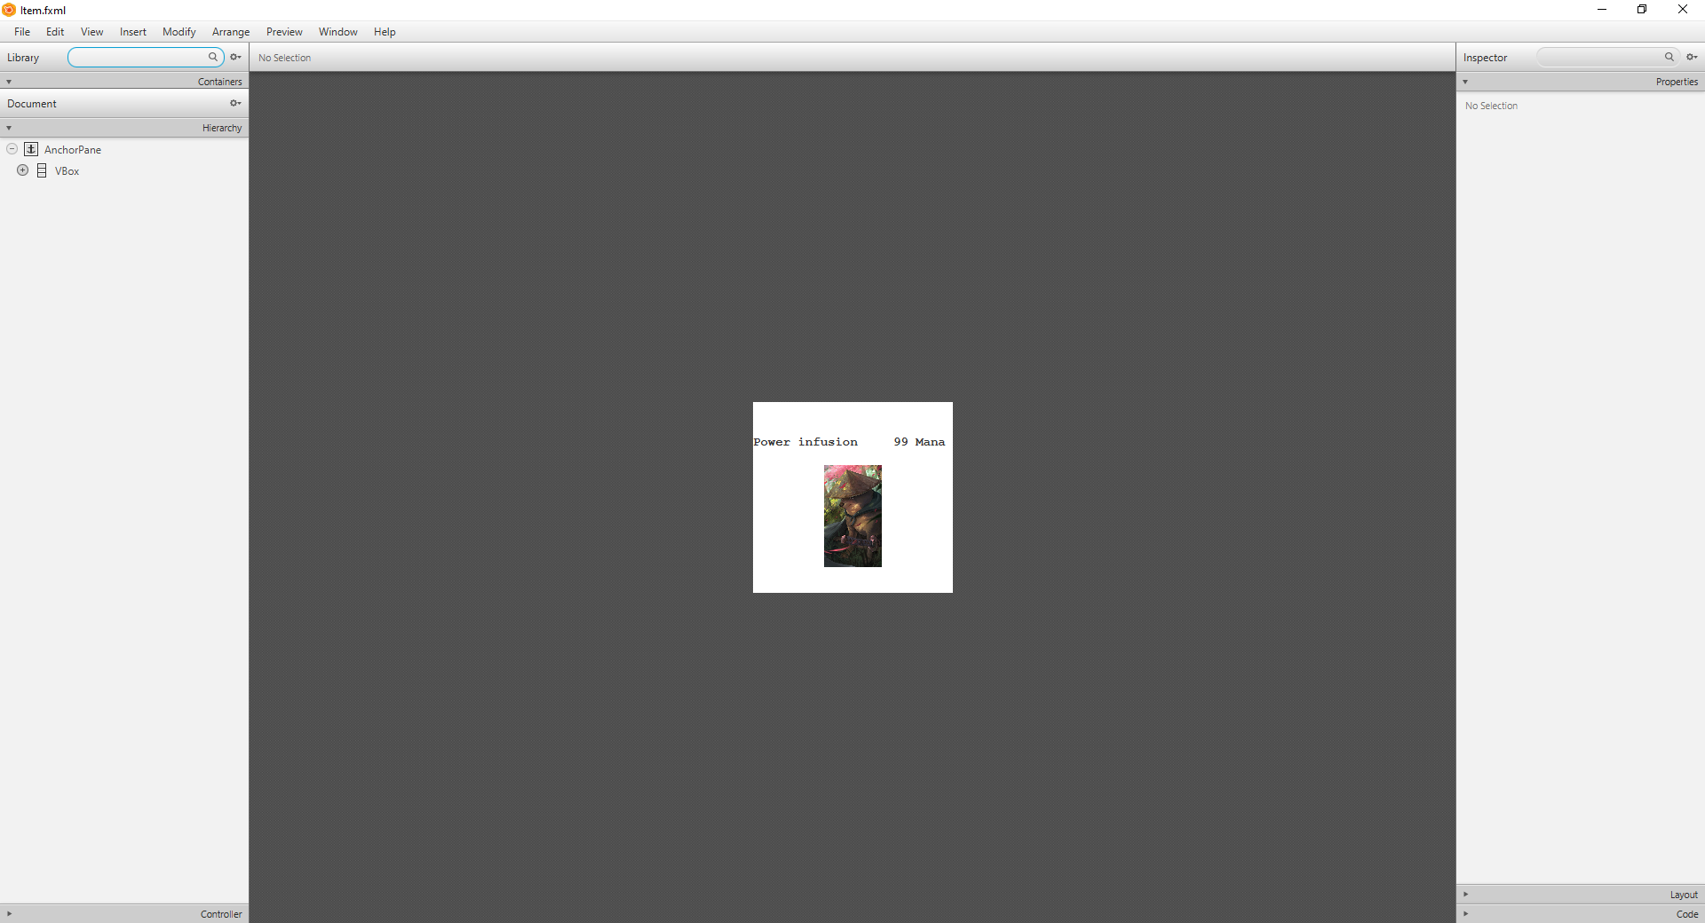

(4.5) MainMenu.fxml

This type of file shows Main Menu scene

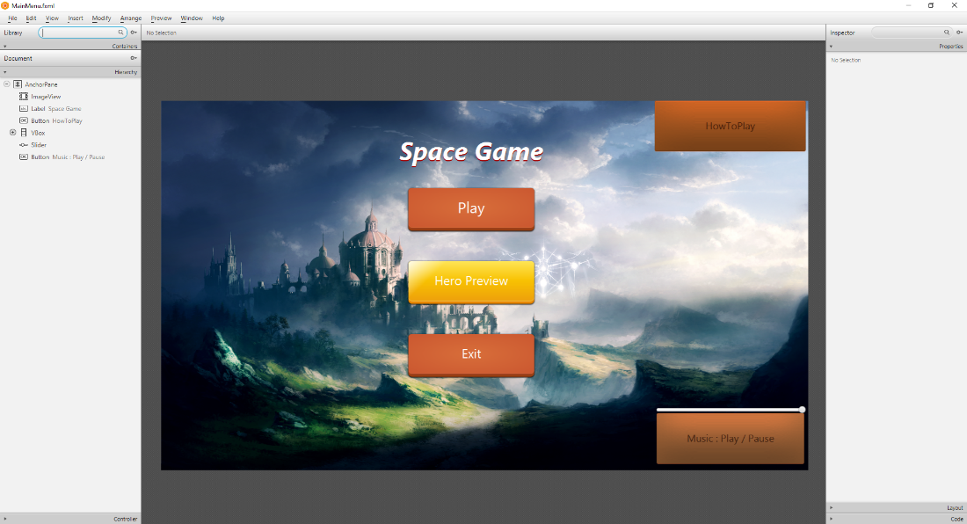

(4.6) MinionSlot.fxml

This type of file shows Item pane that shows in Game Board

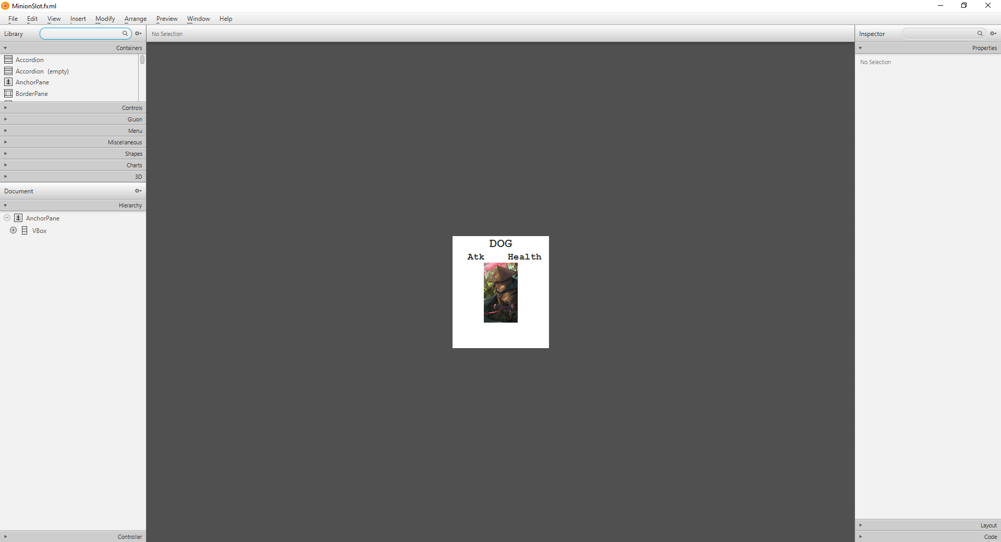

(4.7) Option.fxml

This type of file shows Option scene

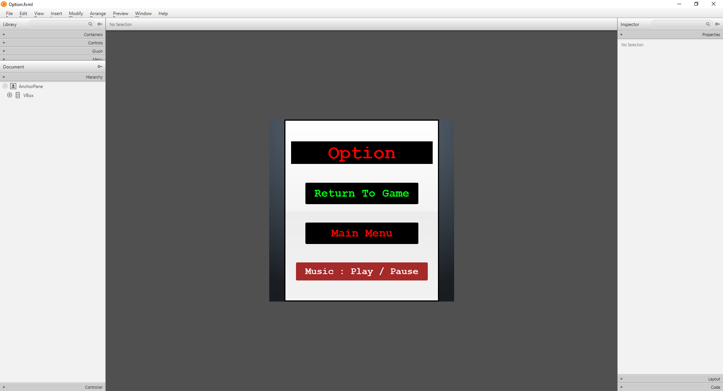

(4.8) SelectHero.fxml

This type of file shows Select Hero scene

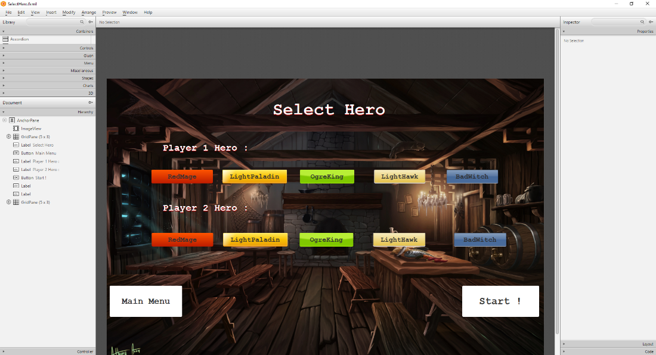

(4.9) Shop.fxml

This type of file shows Shop scene

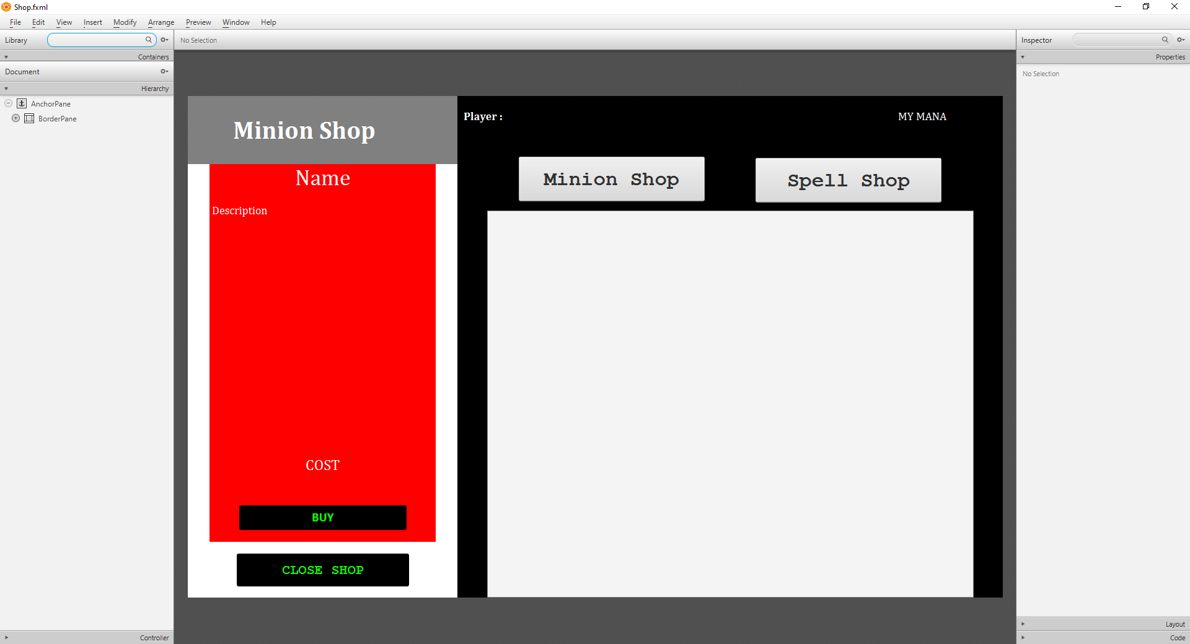

**5. Package object**

**(5.1) Package basecard**

**(5.1.1) abstract class Card**

This class contains the mother class. Spell card, Minion card extends this class.

**(5.1.1.1) Fields**

|  |  |
| --- | --- |
| **Name** | **Description** |
| - String name | - Name of card |
| - String description | - Description of card |

**(5.1.1.2) Constructor**

|  |  |
| --- | --- |
| **Name** | **Description** |
| # Card(String name, String description) | - Set name as name  - Set description as description |

**(5.1.1.3) Methods**

|  |  |
| --- | --- |
| **Name** | **Description** |
| + Getter and Setter for each field |  |

**(5.1.2) abstract class Hero extends Card**

This class is the mother class of minions such as Dog, Dragon, Earth Spirit and other more.

**(5.1.2.1) Fields**

|  |  |
| --- | --- |
| **Name** | **Description** |
| - String name | -Name of hero |
| - String description | -Description of hero |
| - Spell power | -Power of hero |

**(5.1.2.2) Constructor**

|  |  |
| --- | --- |
| **Name** | **Description** |
| + Hero(String name, String description, int health, Spell power) | - Set name as name  - Set description as description  - Set health as health  - Set power as power |

**(5.1.2.3) Methods**

|  |  |
| --- | --- |
| **Name** | **Description** |
| + Getters and Setters |  |

**(5.1.3) abstract class Minion extends Card**

This type of card can attack minion and player

**(5.1.3.1) Fields**

|  |  |
| --- | --- |
| **Name** | **Description** |
| # int attack | -Attack stat of minion |
| # int health | -Health stat of minion |
| # int level | -Level of minion |
| # int maxHealth | -The highest health that minion has. |
| # int maxAttack | -The highest attack that minion can produce. |
| # int cost | -The cost that player must pay to summon |
| # boolean isDead | - Show if the minion is dead or not |
| # Player owner | -The player that owns the minion |

**(5.1.3.2) Constructor**

|  |  |
| --- | --- |
| **Name** | **Description** |
| + Minion(String name, String description,  int attack, int health, int level, Player owner) | Set name as name  Set description as description  Set attack as attack  Set health as health  Set level as level  Set owner as owner  Set dead as false  Set maxHealth as health  Set maxAttack as attack  Set imageUrl as name  Set shopUrl as name  Set boardUrl as name  Set index as 0  Set cost as level * 5 |

**(5.1.3.3) Methods**

|  |  |
| --- | --- |
| **Name** | **Description** |
| + void buffMinion(int buffAttack,  int buffHealth) | - set its maxhealth to its currenthealth by augmenting buff Health  - set its maxattack to its currentattack by augmenting buffattack  - set its health to its currenthealth by augmenting buffHealth  - set its attack to its currentattack by augmenting buffattack |
| + abstract void cast(Minion target) | Method for minion to attack other minion |
| + abstract void cast(Player target) | Method for minion to attack player when the opponent’s field is empty |
| + void healMinion(int healHealth) | If the health of minion is more than its maxhealth after augment healHealth to its current health, set it to maxHealth.  Otherwise, augment healHealth to it |
| + void damageMinion(int damage) | Set health of minion to minion health - damage |
| + Getter and Setter for each field |  |

**(5.1.4) abstract class Spell extends Card**

This class is the mother class of spells in the game such as Buff, Heal, Instant Kill.

**(5.1.4.1) Fields**

|  |  |
| --- | --- |
| **Name** | **Description** |
| - int level | -Level of spell |
| - int cost | -The cost of spell to cast |
| - String url | -The picture of the card |
| - String cardUrl | -The card that contains the picture |

**(5.1.4.2) Constructor**

|  |  |
| --- | --- |
| **Name** | **Description** |
| + Spell(String name, String description,  int level) | Set name as name  Set description as description |

**(5.1.4.3) Methods**

|  |  |
| --- | --- |
| **Name** | **Description** |
| + Getter and Setter for each field |  |

**(5.2) Package heroes**

**(5.2.1) BadWitch class extends Hero**

**This class is one of the hero that player can play with. It’s power is Inner Rage**

**It’s health is 35.**

**(5.2.1.1) Fields**

|  |  |
| --- | --- |
| **Name** | **Description** |
| - final Innerrage power | -Changing the power same as health |

**(5.2.1.2) Constructor**

|  |  |
| --- | --- |
| **Name** | **Description** |
| + BadWitch() | -Set name as “Bad Witch”  -Set Description as “OUTLAW MAGICIAN”  -Set health as 35 |

**(5.2.1.3) Method**

|  |  |
| --- | --- |
| **Name** | **Description** |
| + Innerrage getPower() | -Return Innerrage spell |

**(5.2.2) LightHawk extends Hero**

**This class is one of the hero that player can play with. It’s power is Buff**

**It’s health is 40.**

**(5.2.2.1) Fields**

|  |  |
| --- | --- |
| **Name** | **Description** |
| - final Buff power | -Increase power stat to Hero |

**(5.2.2.2) Constructor**

|  |  |
| --- | --- |
| **Name** | **Description** |
| + LightHawk | -Set name as “Light Hawk”  -Set Description as “IS THAT HAWK OR EAGLE?”  -Set health as 40 |

**(5.2.2.3) Method**

|  |  |
| --- | --- |
| **Name** | **Description** |
| + Buff getPower() | -Return Buff spell |

**(5.2.3) LightPaladin extends Hero**

**This class is one of the hero that player can play with. It’s power is Heal**

**It’s health is 50.**

**(5.2.3.1) Fields**

|  |  |
| --- | --- |
| **Name** | **Description** |
| - final Heal power | -Regen 2-point Hero’s health (can’t regain health over the max health stat of the Hero) |

**(5.2.3.2) Constructor**

|  |  |
| --- | --- |
| **Name** | **Description** |
| + LightPaladin | -Set name as “Light Paladin”  -Set description as “PALADIN OF THE LIGHT TEMPLE”  -Set health as 50 |

**(5.2.3.3) Method**

|  |  |
| --- | --- |
| **Name** | **Description** |
| + Heal getPower() | -Return Heal spell |

**(5.2.4) OrgeKing extends Hero**

**This class is one of the hero that player can play with. It’s power is Quick Recruit**

**It’s health is 40.**

**(5.2.4.1) Fields**

|  |  |
| --- | --- |
| **Name** | **Description** |
| - final Quickrecruit power | - Set power of hero as Quickrecruit |

**(5.2.4.2) Constructor**

|  |  |
| --- | --- |
| **Name** | **Description** |
| + OgreKing | - Set name as “Orge King”  - Set description as “KING OF ORGE HOARD”  - Set health as 40 |

**(5.2.4.3) Method**

|  |  |
| --- | --- |
| **Name** | **Description** |
| + Quickrecruit getPower() | - Return Quickrecruit spell |

**(5.2.5) RedMage extends Hero**

**This class is one of the hero that player can play with. It’s power is Fireblast.**

**It’s health is 35.**

**(5.2.5.1) Fields**

|  |  |
| --- | --- |
| **Name** | **Description** |
| - final Fireblast power | - Take damage 1 point to minion |

**(5.2.5.2) Constructor**

|  |  |
| --- | --- |
| **Name** | **Description** |
| + RedMage | - Set name as “Red Mage”  - Set description as “TOP TIER MAGE OF THE MAGIC”  - Set health as 35 |

**(5.2.5.3) Method**

|  |  |
| --- | --- |
| **Name** | **Description** |
| + Fireblast getPower() | - Return Fireblast spell |

**(5.3) Package minions**

**(5.3.1) Dog class extends Minion**

**This class is one of the minions in the game. It has special effects when brawls**

**(5.3.1.1) Fields**

**This class contains no fields**.

**(5.3.1.2) Constructor**

|  |  |
| --- | --- |
| **Name** | **Description** |
| + Dog() | - Set name as “Dog”  - Set description as “GOOD DOGGO, +3 ATTACK WHEN BRAWL”  - Set its attack to 1  - Set its health to 2 |
| + Dog(int attack, int health) | - Set name as “Dog”  - Set description as “GOOD DOGGO, +3 ATTACK WHEN BRAWL”  - Set its attack to attack  - Set its health to health |

**(5.3.1.3) Method**

|  |  |
| --- | --- |
| **Name** | **Description** |
| + void cast (Minion target) | - Set int damage to 0  - if this minion attack + 3 is more than that target’s health set damage equals to this minion attack +3 minus the target's health  - damage target equal to this minion attack  - damage this minion equal to target attack  - damage target owner to equals to damage |
| + void castPlayer (Player target) | - damage player equal to this minion attack |

**(5.3.2) Dragon class extends Minion**

**This class is one of the minions in the game. It doesn’t have special effects when brawls**

**(5.3.2.1) Fields**

This class contains no fields.

**(5.3.2.2) Constructor**

|  |  |
| --- | --- |
| **Name** | **Description** |
| + Dragon() | - Set name as “Dragon”  - Set description as” LEGENDARY CREATURE”  - Set its attack to 12  - Set its health to 12 |
| + Dragon(int attack, int health) | - Set name as “Dragon”  - Set description as” LEGENDARY CREATURE”  - Set its attack to attack  - Set its health to health |

**(5.3.2.3) Method**

|  |  |
| --- | --- |
| **Name** | **Description** |
| + void cast (Minion target) | - Set int damage to 0  - if this minion attack is more than that target’s health set damage equals to this minion attack minus the target's health  - damage target equal to this minion attack  - damage this minion equal to target attack  - damage target owner to equals to damage |
| + void castPlayer (Player target) | - damage player equal to this minion attack |

**(5.3.3) EarthSpirit class extends Minion**

**This class is one of the minions in the game. It doesn’t have special effects when brawls**

**(5.3.3.1) Fields**

This class contains no fields.

**(5.3.3.2) Constructor**

|  |  |
| --- | --- |
| **Name** | **Description** |
| + EarthSpirit() | - Set name as “Earth Spirit”  - Set description as “SPIRIT OF EARTH”  - Set its attack to 3  - Set its health to 12 |
| + EarthSpirit(int attack, int health) | - Set name as “Earth Spirit”  - Set description as “SPIRIT OF EARTH”  - Set its attack to attack  - Set its health to health |

**(5.3.3.3) Method**

|  |  |
| --- | --- |
| **Name** | **Description** |
| + void cast (Minion target) | - Set int damage to 0  - if this minion attack is more than that target’s health set damage equals to this minion attack minus the target's health  - damage target equal to this minion attack  - damage this minion equal to target attack  - damage target owner to equals to damage |
| + void castPlayer (Player target) | - damage player equal to this minion attack |

**(5.3.4) FireSpirit class extends Minion**

**This class is one of the minions in the game. It doesn’t have special effects when brawls**

**(5.3.4.1) Fields**

This class contains no fields.

**(5.3.4.2) Constructor**

|  |  |
| --- | --- |
| **Name** | **Description** |
| + FireSpirit() | - Set name as “Fire Spirit”  - Set description as “SPIRIT OF FIRE”  - Set its attack to 3  - Set its health to 1 |
| + FireSpirit(int attack, int health) | - Set name as “Fire Spirit”  - Set description as “SPIRIT OF FIRE”  - Set its attack to attack  - Set its health to health |

**(5.3.4.3) Method**

|  |  |
| --- | --- |
| **Name** | **Description** |
| + void cast (Minion target) | - Set int damage to 0  - if this minion attack is more than that target’s health set damage equals to this minion attack minus the target's health  - damage target equal to this minion attack  - damage this minion equal to target attack  - damage target owner to equals to damage |
| + void castPlayer (Player target) | - damage player equal to this minion attack |

**(5.3.5) George class extends Minion**

**This class is one of the minions in the game. It has special effects when brawls.**

**(5.3.5.1) Fields**

This class contains no fields.

**(5.3.5.2) Constructor**

|  |  |
| --- | --- |
| **Name** | **Description** |
| + George() | - Set name as “George”  - Set description as “HIGHSCHOOL GENIUS\n HEAL BACK TO MAX HEALTH EVERY TIME IT’S ATTACK”  - Set its attack to 1  - Set its health to 4 |
| + George(int attack, int health) | - Set name as “George”  - Set description as “HIGHSCHOOL GENIUS\n HEAL BACK TO MAX HEALTH EVERY TIME IT’S ATTACK”  - Set its attack to attack  - Set its health to health |

**(5.3.5.3) Method**

|  |  |
| --- | --- |
| **Name** | **Description** |
| + void cast (Minion target) | - Set int damage to 0  - if this minion attack is more than that target’s health set damage equals to this minion attack minus the target's health  - damage target equal to this minion attack  - damage this minion equal to target attack  - damage target owner to equals to damage  - if isDead is false set this minion health to this minion max health |
| + void castPlayer (Player target) | - damage player equal to this minion attack |

**(5.3.6) Gobuta class extends Minion**

**This class is one of the minions in the game. It doesn’t have special effects when brawls**

**(5.3.6.1) Fields**

This class contains no fields

**(5.3.6.2) Constructor**

|  |  |
| --- | --- |
| **Name** | **Description** |
| + Gobuta() | - Set name as “Gobuta”  - Set description as “STUPID GOBLIN”  - Set its attack to 1  - Set its health to 3 |
| + Gobuta(int attack, int health) | - Set name as “Gobuta”  - Set description as “STUPID GOBLIN”  - Set its attack to attack  - Set its health to health |

(5.3.6.3) Method

|  |  |
| --- | --- |
| **Name** | **Description** |
| + void cast (Minion target) | - Set int damage to 0  - if this minion attack is more than that target’s health set damage equals to this minion attack minus the target's health  - damage target equal to this minion attack  - damage this minion equal to target attack  - damage target owner to equals to damage |
| + void castPlayer (Player target) | - damage player equal to this minion attack |

**(5.3.7) HobGoblin class extends Minion**

**This class is one of the minions in the game. It doesn’t have special effects when brawls**

**(5.3.7.1) Fields**

This class contains no fields.

**(5.3.7.2) Constructor**

|  |  |
| --- | --- |
| **Name** | **Description** |
| + HobGoblin() | - Set name as “Hob Goblin”  - Set description as “STUPID GOBLIN BUT WITH MUSCLE”  - Set its attack to 5  - Set its health to 5 |
| + HobGoblin(int attack, int health) | - Set name as “Hob Goblin”  - Set description as “STUPID GOBLIN BUT WITH MUSCLE”  - Set its attack to attack  - Set its health to health |

**(5.3.7.3) Method**

|  |  |
| --- | --- |
| **Name** | **Description** |
| + void cast (Minion target) | - Set int damage to 0  - if this minion attack is more than that target’s health set damage equals to this minion attack minus the target's health  - damage target equal to this minion attack  - damage this minion equal to target attack  - damage target owner to equals to damage |
| + void castPlayer (Player target) | - damage player equal to this minion attack |

**(5.3.8) Knight class extends Minion**

**This class is one of the minions in the game. It doesn’t have special effects when brawls**

**(5.3.8.1) Fields**

This class contains no fields.

**(5.3.8.2) Constructor**

|  |  |
| --- | --- |
| **Name** | **Description** |
| + Knight() | - Set name as “Knight”  - Set description as “JUST SOME GUY WITHSOME ARMORY”  - Set its attack to 3  - Set its health to 7 |
| + Knight(int attack, int health) | - Set name as “Knight”  - Set description as “JUST SOME GUY WITHSOME ARMORY”  - Set its attack to attack  - Set its health to health |

**(5.3.8.3) Method**

|  |  |
| --- | --- |
| **Name** | **Description** |
| + void cast (Minion target) | - - Set int damage to 0  - if this minion attack is more than that target’s health set damage equals to this minion attack minus the target's health  - damage target equal to this minion attack  - damage this minion equal to target attack  - damage target owner to equals to damage |
| + void castPlayer (Player target) | - damage player equal to this minion attack |

**(5.3.9) MuscleDude class extends Minion**

**This class is one of the minions in the game. It has special effects when brawls.**

**(5.3.9.1) Fields**

This class contains no fields.

**(5.3.9.2) Constructor**

|  |  |
| --- | --- |
| **Name** | **Description** |
| + MuscleDude() | - Set name as “Muscle Dude”  - Set description as “GUY WITH MUSCLE –2 ATTACK AND –2 HEALTH AFTER BRAWL”  - Set its attack to 9  - Set its health to 9 |
| + MuscleDude(int attack, int health) | - Set name as “Muscle Dude”  - Set description as “GUY WITH MUSCLE –2 ATTACK AND –2 HEALTH AFTER BRAWL”  - Set its attack to attack  - Set its health to health |

**(5.3.9.3) Method**

|  |  |
| --- | --- |
| **Name** | **Description** |
| + void cast (Minion target) | - Set int damage to 0  - if this minion attack is more than that target’s health set damage equals to this minion attack minus the target's health  - damage target equal to this minion attack  - damage this minion equal to target attack  - damage target owner to equals to damage  - if isDead is false set this minion max health to minus 2 set this minion attack to minus 2 |
| + void castPlayer (Player target) | - damage player equal to this minion attack  - set this minion max health to minus 2  - set this minion attack to minus 2 |

**(5.3.10) Priest class extends Minion**

**This class is one of the minions in the game. It has special effects when brawls.**

**(5.3.10.1) Fields**

This class contains no fields.

**(5.3.10.2) Constructor**

|  |  |
| --- | --- |
| **Name** | **Description** |
| + Priest() | - Set name as “Priest”  - Set description as “HIGH CLASS PRIEST\n HEAL OPPONENT TO 15 HEALTH EVERY TIME IT’S ATTACK”  - Set its attack to 20  - Set its health to 20 |
| + Priest (int attack, int health) | - Set name as “Priest”  - Set description as “HIGH CLASS PRIEST\n HEAL OPPONENT TO 15 HEALTH EVERY TIME IT’S ATTACK”  - Set its attack to attack  - Set its health to health |

**(5.3.10.3) Method**

|  |  |
| --- | --- |
| **Name** | **Description** |
| + void cast (Minion target) | - Set int damage to 0  - if this minion attack is more than that target’s health set damage equals to this minion attack minus the target's health  - damage target equal to this minion attack  - damage this minion equal to target attack  - damage target owner to equals to damage  - heal target owner for 20 |
| + void castPlayer (Player target) | - damage player equal to this minion attack  - heal target owner for 20 |

**(5.3.11) Ragnaros class extends Minion**

**This class is one of the minions in the game. It doesn’t have special effects when brawls but when it attacks player, the damage player receive is its base attack.**

**(5.3.11.1) Fields**

This class contains no fields.

**(5.3.11.2) Constructor**

|  |  |
| --- | --- |
| **Name** | **Description** |
| + Ragnaros() | - Set name as “Ragnaros”  - Set description as “MYSTICAL FIRE GOD\n HEAL OPPONENT TO 15 HEALTH EVERY TIME IT’S ATTACK”  - Set its attack to 20  - Set its health to 20 |
| + Ragnaros(int attack, int health) | **Description** |
|  | - Set name as “Ragnaros”  - Set description as “MYSTICAL FIRE GOD\n HEAL OPPONENT TO 15 HEALTH EVERY TIME IT’S ATTACK”  - Set its attack to attack  - Set its health to health |

**(5.3.11.3) Method**

|  |  |
| --- | --- |
| **Name** | **Description** |
| + void cast (Minion target) | - Set int damage to 0  - if 8 is more than that target’s health set damage equals to this minion attack minus the target's health  - damage target equal to this 8  - damage this minion equal to target attack  - damage target owner to equals to damage |
| + void castPlayer (Player target) | - damage player equal to this minion attack |

**(5.3.12) RealWarrior class extends Minion**

This class is one of the minions in the game. It has special effects when brawls.

**(5.3.12.1) Fields**

This class contains no fields.

**(5.3.12.2) Constructor**

|  |  |
| --- | --- |
| **Name** | **Description** |
| + RealWarrior() | - Set name as “Real Warrior”  - Set description as “IF THIS MINION DIE BY BRAWL WHEN ATTACK WITH OTHER MINION WIN THE GAME”  - Set its attack to 1  - Set its health to 10 |
| + RealWarrior(int attack, int health) | - Set name as “Real Warrior”  - Set description as “IF THIS MINION DIE BY BRAWL WHEN ATTACK WITH OTHER MINION WIN THE GAME”  - Set its attack to attack  - Set its health to health |

**(5.3.12.3) Method**

|  |  |
| --- | --- |
| **Name** | **Description** |
| + void cast (Minion target) | - Set int damage to 0  - if this minion attack is more than that target’s health set damage equals to this minion attack minus the target's health  - damage target equal to this minion attack  - damage this minion equal to target attack  - damage target owner to equals to damage  - if isDead is true set damage to player hero health |
| + void castPlayer (Player target) | - damage player equal to this minion attack |

**(5.3.13) Spider class extends Minion**

This class is one of the minions in the game. It doesn’t has special effects when brawls.

**(5.3.13.1) Fields**

This class contains no fields.

**(5.3.13.2) Constructor**

|  |  |
| --- | --- |
| **Name** | **Description** |
| + Spider() | - Set name as “Spider”  - Set description as “SPOOKY SPIDER”  - Set its attack to 2  - Set its health to 2 |
| + Spider(int attack, int health) | Set name as “Spider”  - Set description as “SPOOKY SPIDER”  - Set its attack to attack  - Set its health to health |

**(5.3.13.3) Method**

|  |  |
| --- | --- |
| **Name** | **Description** |
| + void cast (Minion target) | - Set int damage to 0  - if this minion attack is more than that target’s health set damage equals to this minion attack minus the target's health  - damage target equal to this minion attack  - damage this minion equal to target attack  - damage target owner to equals to damage |
| + void castPlayer (Player target) | - damage player equal to this minion attack |

**(5.3.14) SpiderCave class extends Minion**

This class is one of the minions in the game. It has special effects when brawls.

**(5.3.14.1) Fields**

This class contains no fields.

**(5.3.14.2) Constructor**

|  |  |
| --- | --- |
| **Name** | **Description** |
| + SpiderCave() | - Set name as “Spider Cave”  - Set description as “HUGE STINKY -SPIDER”  - Set its attack to 9  - Set its health to 3 |
| + SpiderCave(int attack, int health) | - Set name as “Spider Cave”  - Set description as “HUGE STINKY -SPIDER”  - Set its attack to attack  - Set its health to health |

**(5.3.14.3) Method**

|  |  |
| --- | --- |
| **Name** | **Description** |
| + void cast (Minion target) | - Set int damage to 0  - if this minion attack is more than that target’s health set damage equals to this minion attack minus the target's health  - damage target equal to this minion attack  - damage this minion equal to target attack  - damage target owner to equals to damage  - if target doesn’t die after set target health to 0 |
| + void castPlayer (Player target) | - damage player equal to this minion attack |

**(5.3.15) Yog class extends Minion**

This class is one of the minions in the game. It has special effects when brawls.

**(5.3.15.1) Fields**

This class contains no fields.

**(5.3.15.2) Constructor**

|  |  |
| --- | --- |
| **Name** | **Description** |
| + Yog() | - Set name as “Yog”  - Set description as “MYSTERIOUS CREATURE\n DESTROY ALL MINION WHEN ATTACK CANNOT INFLICT DAMEGE”  - Set its attack to 0  - Set its health to 30 |
| + Yog (int attack, int health) | - Set name as “Yog”  - Set description as “MYSTERIOUS CREATURE\n DESTROY ALL MINION WHEN ATTACK CANNOT INFLICT DAMEGE”  - Set its attack to attack  - Set its health to health |

**(5.3.15.3) Method**

|  |  |
| --- | --- |
| **Name** | **Description** |
| + void cast (Minion target) | - Set int damage to 0  - damage this minion equal to target attack |
| + void castPlayer (Player target) | - damage player equal to 0 |

**(5.4) Package spells**

**(5.4.1) Bindingheal class extends Spell implements BuffMinion**

This class needs to cast to own player minion only

**(5.4.1.1) Fields**

This class contains no fields

**(5.4.1.2) Constructor**

|  |  |
| --- | --- |
| **Name** | **Description** |
| + Bindingheal() | - Set name as “Bindingheal”  - Set description as “HEAL 5 HEALTH OF THE TARGET AND YOUR HERO”  - Set its cost to 5 |

**(5.4.1.3) Methods**

|  |  |
| --- | --- |
| **Name** | **Description** |
| + cast(Minion target) | - Increase health of minion and player by 5 |

**(5.4.2) Buff class extends Spell implements BuffMinion**

This class needs to cast to own player minion only

**(5.4.2.1) Fields**

This class contains no fields

**(5.4.2.2) Constructor**

|  |  |
| --- | --- |
| **Name** | **Description** |
| + Buff() | - Set name as “Buff” - Set description as “INCREASE 1 ATTACK AND 2 HEALTH OF THE TARGET” - Set its cost to 4 |

**(5.4.2.3) Methods**

|  |  |
| --- | --- |
| **Name** | **Description** |
| + cast(Minion target) | - Increase attack of minion by 1 and health by 2 |

**(5.4.3) Boink class extends Spell**

This class can cast directly

**(5.4.3.1) Fields**

This class contains no fields

**(5.4.3.2) Constructor**

|  |  |
| --- | --- |
| **Name** | **Description** |
| + Boink() | - Set name as “Boink”  - Set description as “DAMAGE OPPONENT HERO 5 DAMAGE” - Set its cost to 8 |

**(5.4.1.3) Methods**

|  |  |
| --- | --- |
| **Name** | **Description** |
| + cast(Minion target) | - Set player by checking GameLogic.checkPLayer()  - If playerOne equals to player, Logic.GameLogic.playerTwo.takeDamage(5)  - If playerTwo equals to player, Logic.GameLogic.playerOne.takeDamage(5) |

**(5.4.4) Doom class extends Spell implements AttackMinion**

This class has to cast on enemy’s minion

**(5.4.4.1) Fields**

This class contains no fields

**(5.4.4.2) Constructor**

|  |  |
| --- | --- |
| **Name** | **Description** |
| + Doom() | - Set name as “Doom”  - Set description as “DESTROY ALL MINIONS IN OPPONENT FIELD”  - Set its cost to 20 |

**(5.4.4.3) Methods**

|  |  |
| --- | --- |
| **Name** | **Description** |
| + cast(Player target) | - Destroy all minions in opponent field |

**(5.4.5) Fireball class extends Spell implements AttackMinion**

This class has to cast on enemy’s minion

**(5.4.5.1) Fields**

This class contains no fields

**(5.4.5.2) Constructor**

|  |  |
| --- | --- |
| **Name** | **Description** |
| + Fireball() | - Set name as “Fireball”  - Set description as “REDUCE 6 HEALTH OF THE TARGET”  - Set its cost to |

**(5.4.5.3) Methods**

|  |  |
| --- | --- |
| **Name** | **Description** |
| + cast(Minion target) | - Reduce health of minion by 6 |

**(5.4.6) Fireblast class extends Spell implements AttackMinion**

This class has to cast on enemy’s minion

**(5.4.6.1) Fields**

This class contains no fields

**(5.4.6.2) Constructor**

|  |  |
| --- | --- |
| **Name** | **Description** |
| + Fireblast() | - Set name as “Fireblast”  - Set description as “REDUCE 1 HEALTH OF THE TARGET”  - Set level as 1 |

**(5.4.6.3) Methods**

|  |  |
| --- | --- |
| **Name** | **Description** |
| + cast(Minion target) | - Reduce health of minion by 1 |

**(5.4.7) Firerings class extends Spell implements AttackMinion**

This class has to cast on enemy’s minion

**(5.4.7.1) Fields**

This class contains no fields

**(5.4.7.2) Constructor**

|  |  |
| --- | --- |
| **Name** | **Description** |
| + Firerings() | - Set name as “Firerings”  - Set description as “REDUCE 1 HEALTH OF ALL OPPONENT MINIONS”  - Set level as 2 |

**(5.4.7.3) Methods**

|  |  |
| --- | --- |
| **Name** | **Description** |
| + cast(Player target) | - Reduce health of all opponent minions by 1 |

**(5.4.8) Heal class extends Spell implements BuffMinion**

This class has to cast on player minion

**(5.4.8.1) Fields**

This class contains no fields

**(5.4.8.2) Constructor**

|  |  |
| --- | --- |
| **Name** | **Description** |
| + Heal() | - Set name as “Heal”  - Set description as “HEAL 2 HEALTH OF THE TARGET”  - Set level as 1 |

**(5.4.8.3) Methods**

|  |  |
| --- | --- |
| **Name** | **Description** |
| + cast(Player target) | - Increase health of player by 2 |
| + cast(Minion target) | - Increase health of minion by 2 |

**(5.4.9) Innerrage class extends Spell implements AttackMinion**

This class can cast spell on enemy minion or player minion

**(5.4.9.1) Fields**

This class contains no fields

**(5.4.9.2) Constructor**

|  |  |
| --- | --- |
| **Name** | **Description** |
| + Innerrage() | - Set name as “Innerrage”  - Set description as “SET MINION ATTACK EQUAL TO THEIR HEALTH”  - Set level as 1 |

**(5.4.9.3) Methods**

|  |  |
| --- | --- |
| **Name** | **Description** |
| + cast(Minion target) | - Set minion attack equal to their health |

**(5.4.10) InstantKill class extends Spell implements AttackMinion**

This class have to cast on enemy’s minion

**(5.4.10.1) Fields**

This class contains no fields

**(5.4.10.2) Constructor**

|  |  |
| --- | --- |
| **Name** | **Description** |
| + InstantKill() | - Set name as “InstantKill”  - Set description as “DESTROY TARGET MINION”  - Set level as 3 |

(5.4.10.3) Methods

|  |  |
| --- | --- |
| **Name** | **Description** |
| + cast(Minion target) | - Destroy minion |

**(5.4.11) Legend class extends Spell implements SpawnMinion**

This class can be cast directly

**(5.4.11.1) Fields**

This class contains no fields

**(5.4.11.2) Constructor**

|  |  |
| --- | --- |
| **Name** | **Description** |
| + Legend() | - Set name as “Legend”  - Set description as “SUMMON 12 HEALTH AND 12 ATTACK MINION”  - Set level as 3 |

**(5.4.11.3) Methods**

|  |  |
| --- | --- |
| **Name** | **Description** |
| + cast(Player target) | - Summon minion with 12 health and attack |

**(5.4.12) Massheal class extends Spell implements BuffMinion**

This class have to cast on player minion

**(5.4.12.1) Fields**

This class contains no fields

**(5.4.12.2) Constructor**

|  |  |
| --- | --- |
| **Name** | **Description** |
| + Massheal() | - Set name as “Massheal”  - Set description as “HEAL 2 HEALTH OF ALL ALLY MINIONS”  -Set level as 2 |

(5.4.12.3) Methods

|  |  |
| --- | --- |
| **Name** | **Description** |
| + cast(Player player) | - Increase all ally health by 2 |

**(5.4.13) Poison class extends Spell implement AttackMinion**

This class has to cast on enemy minon

**(5.4.11.1) Fields**

This class contains no fields

**(5.4.11.2) Constructor**

|  |  |
| --- | --- |
| **Name** | **Description** |
| + Poison() | - Set name as “Poison”  - Set description as “REDUCE HEALTH OF ALL OPPONENT MINIONS BY TARGET MINION ATTACK THEN DESTROY THAT MINION”  - Set level as 3 |

**(5.4.11.3) Methods**

|  |  |
| --- | --- |
| **Name** | **Description** |
| + cast(Player target) | - Reduce all opponent minions' health by target minion attack then destroy that minion |

**(5.4.14) Powerinfusion class extends Spell implement BuffMinion**

This class has to cast on player minion

**(5.4.14.1) Fields**

This class contains no fields

**(5.4.14.2) Constructor**

|  |  |
| --- | --- |
| **Name** | **Description** |
| + Powerinfusion() | - Set name as “Powerinfusion”  - Set description as “INCREASE 2 ATTACK AND 6 HEALTH OF THE TARGET”  -Set level as 3 |

**(5.4.14.3) Methods**

|  |  |
| --- | --- |
| **Name** | **Description** |
| + cast(Minion target) | - Increase attack of minion by 2 and health of minion by 6 |

**(5.4.15)** **Quickrecruit** **class extends Spell implement SpawnMinion**

This class has to cast directly

**(5.4.15.1) Fields**

This class contains no fields

**(5.4.15.2) Constructor**

|  |  |
| --- | --- |
| **Name** | **Description** |
| + Quickrecruit() | - Set name as “Quickrecruit”  - Set description as “SUMMON 1 LEVEL GOBUTA”  -Set le |

**(5.4.15.3) Methods**

|  |  |
| --- | --- |
| **Name** | **Description** |
| + cast(Player player) | -Summon 1 level Gobuta |

**6. Package player**

**(6.1) Player class**

This class represents of each player's essential information.

**(6.1.1) Fields**

|  |  |
| --- | --- |
| **Name** | **Description** |
| - ArrayList<Minion> minionBoard | Store player’s minions in ArrayList |
| - Hero hero | Store hero of player |
| - int health | Store health of player |
| - int mana | Store player mana |

**(6.1.2) Constructor**

|  |  |
| --- | --- |
| **Name** | **Description** |
| + Player(String name, Hero hero) | - Set minionBoard as minionBoard  - Set Hero as hero  - Set mana to 5  - Set health same as hero health |

**(6.1.3) Methods**

|  |  |
| --- | --- |
| **Name** | **Description** |
| + void resetHealth() | - Set player health to hero base health |
| + void takeDamage(int damage) | - Set player health after taking damage |
| + void healDamage(int heal) | - Set player health after healing |
| + void setIndexMinion() | - Initialize int variable as c and set it to 0  - loop Minion minion in this.getMinionBoard(), set minion index by calling minion.setIndex(c) , increase c by 1 every time the loop ends |
| + void spawnMinion(ArrayList<Minion> minionBoard, Minion minion) | - if player’s minionBoard size is less than 5, add minion to player’s minionBoard, call setIndexMinion() and call minion.setOwner(this) |
| + void killMinion | - remove minion from minionBoard |
| + Getter and Setter for each field |  |